****

**جامعة حلوان**

**كلية الحاسبات و الذكاء الاصطناعي**

**قسم نظم المعلومات**

**[Find Me Web Application]**

رسالة مشروع تخرج مقدمة من :

(يوسف بنيامين حليم عبيد الله) (20180701)

(محمد أحمد عبد الله محمد)(20180461)

(كريم عبد المجيد عبد الغني)(20180432)

(محمد رأفت عبد الصالحين محمود)(20180491)

(عبد الله صبري بلتاجي رخا)(20180334)

(عبد المجيد محمد عبد المجيد)(20180343)

رسالة مقدمة ضمن متطلبات الحصول علي درجة البكالوريوس في الحاسبات و الذكاء الاصطناعي، بقسم نظم المعلومات، كلية الحاسبات و الذكاء الاصطناعي، جامعة حلوان

: اشراف تحت

**(د. صفاء مجدي)**

****

****

**Find-Me Web Application**

****

****

**Supervised By**

**Dr. Safaa Magdy**

**Project Team:**

|  |  |
| --- | --- |
| Name | Id |
| Youssef Benyameen Haleem | **20180701** |
| Mohamed Ahmed Abd Allah Mohamed | **20180461** |
| Kareem Abd El Meged Abd El Ghani | **20180432** |
| Mohamed Rafaat Abd El Salheen | **20180491** |
| Abd Allah Sabry Beltagy | **20180334** |
| Abd El Meged Mohamed Abd El Meged | **20180343** |

****

******Abstract:**

kidnapping has become increasingly a common issue in our society in the past few years, for a variety of reasons including human organ trading, murder, theft, and rape.

Every day, we see articles in numerous magazines, newspapers, and social media for lost children, mobile phones, laptops, aged people, and other items, so we decided to create This Web Application to facilitate the search process for a specific something they were searching for.

**🗹** Hundreds of posts are submitted on Facebook groups and other social media platforms each minute.

**🗹** Those Posts are repeated a lot and some posts might be fake or contains inappropriate word or picture.

**🗹** Many People create posts with incomplete information where mobile number is missing or forgot to write the location.

**🗹** You must wait for the admin to approve your post which might take hours or even days to be submitted.

**🗹** No Specification for posts makes it difficult to reach the target one.

**🗹** It is difficult to contact with the author of the article or the post.

**🗹**  Many people create fake accounts to enter these groups and create fake posts for theft or fraud.

**🗹** The inability to find the target post within millions of those posts.

* Our application will intend to solve these problems progressively not all at one time.

****

**Technologies:**

* Asp.Net Core Identity 3.1
* Python
* SQL Server Management studio to link database to the backend to store data like images, application users, comments, posts.
* IIS Express for hosting web application on browser.

**Process:**

* Regular user Process:
* You may need to try this web application without registration to view posts created on the home page, but you will not be able to use the whole website features.
* To register you must enter username, valid email, address, phone number, zip code, password and confirm password.
* You can Also register to the website using your Facebook account.
* You can login with email and password.
* You can view your profile and edit it (Edit Username, Edit Phone Number, Change Email, Create New Password, Delete Account, Add Profile Picture or Change it).
* You can view details of any post posted on the Home Page.
* ****You can search for posts added by a specific user like (username of the author, his/her phone number, his/her email address).

****

* You can add comment to any post on the home page.
* You can create post; you must specify Category (People, Personal belongings, or Pets) and Sub-category (Kids, Mobile Phones, Cats, etc.) of your post.
* You can add a description to your post.
* You can add an image to the post (There is a default image for posts created without an image).
* You can edit your post change image or category or sub-category or description of the post.
* You can check the status of you post whether it is pending, approved, or rejected.
* You can use our new search technique where you can upload an image and return post with image similar to the uploaded one in short time.
* Admin Process:
* You can login with email and password.
* You can view your profile and edit it (Edit Username, Edit Phone Number, Change Email, Create New Password, Delete Account, Add Profile Picture or Change it).
* You can view details of any post posted on the Home Page.
* ****You can add comment to any post on the home page.
* ****You can Lock inactivated accounts and unlock user accounts.
* You can view application users’ details (Username, Phone Number, Address, Zip Code, and Email Address).
* You can Register (a new user or a new admin), enter username, valid email, address, phone number, zip code, password and confirm password.
* You can add, update, or delete category.
* You can add, update, or delete Sub-category.
* You can Approve or Reject pending posts.
* You can check the founded items and remove the post from the home page if it was found.
* You can lock user accounts after five invalid login attempts.
* you can send verification email to users for account confirmation.
* You can send reset password form to users to create new password as they forgot the old one.

****

****

**Table of contents:**

1. **Introduction**: **……………………………………………………… 10**
   1. **Overview**: **……………………………………………………… 11**
   2. **Objectives**: **………………………………………………………12**
   3. **Purpose**: **………………………………………………………13**
   4. **Scope**: **………………………………………………………14**
   5. **General Constraints**: **………………………………………………………18**
2. **Project Planning and Analysis:** **………………………………………………20**
   1. **Project Planning: ………………………………………………………21**
      1. **Feasibility study:** **………………………………………………………21**
      2. **Estimated Cost: ………………………………………………………22**
      3. **Gantt chart:** **………………………………………………………23**
   2. **Analysis and Limitations of existing system: ……………………………25**
   3. **Need for the new system: …………………………………………………31**
   4. **Analysis of the new system: ………………………………………………32**
      1. **User Requirements: ………………………………………………………32**
      2. **System Requirements: ………………………………………………………32**
      3. **Domain Requirements: ………………………………………………………33**
      4. **Functional Requirements: ……………………………………………………34**
      5. **Non-Functional Requirements: ………………………………………………37**
   5. **Advantages of new system: …………………………………………………39**
   6. **Risk and Risk Management: ………………………………………………40**
3. **Software Design: ………………………………………………………43**
   1. **Design of Database (ERD or Class) Diagram: ……………………………44**
   2. **Use Case Diagram:** **………………………………………………………46**
   3. **Sequence Diagram: ………………………………………………………48**
   4. **Activity Diagram: ………………………………………………………67**

****

1. **Implementation: ………………………………………………………74**
   1. **Software Architecture: ………………………………………………………75**
   2. **PseudoCode, Flow Chart or WorkFlow: ………………………………109**
2. **Testing:** **………………………………………………………114**
   1. **Unit testing:** **………………………………………………………115**
   2. **Integrated testing:** **………………………………………………………120**
   3. **Additional testing:** **………………………………………………………124**
3. **Results and Discussion:** **………………………………………………………131**
   1. **Results:** **………………………………………………………132**
      1. **Expected Result:** **………………………………………………………132**
      2. **Actual Result:** **………………………………………………………**
   2. **Discussion:** **………………………………………………………**
4. **Conclusion:** **………………………………………………………**
5. **Future Work:** **………………………………………………………**

****

****

****

**Chapter 1.**

**Introduction**

In this chapter we’re going to discuss and go deeper in the overview of the project and know more about its scope and limitations and explain some terminologies we will find throughout the document.

****

* 1. **Overview:**
* “Find ME” is a web Application that can be used and accessed anytime and anywhere to create or search for anything lost (Human beings, Personal belongings or even pets).
* People can write a post (including picture, description, city, etc.) about the lost item to the public and if it is found someone is going to call or text them or write a comment on their post.
* The Application allow users to search for specific post either by searching for post’s author name, email address or his/her phone number.
* A new technology is added to the application that permits users to upload an image and retrieve the post that contains the image similar to the uploaded one to facilitate the search process.
* Also Posts on the Website are displayed in sequence using paging to facilitate reading posts.
* ****Each post contains details such as address, mobile phone and email address, you can also write a comment to any post which makes it easier to contact with the author.

****

**1.2 Objectives:**

* The website’s objective is to provide an easy way to search for the something the people has lost by using AI Technology (Face Recognition applied only for human beings) which makes it easier and accurate for the search in short specific time (ranges from 2:5 seconds).
* People would be able to write a post on the website easily and attach pictures and write description and provide their address and phone numbers that will help make it easier to find the lost item.
* ****The goals of our project is to provide a web application that help people find their lost items in a very short time and easily, also it could be used by government or the public to find the kidnapped and lost people and connect them with their parents or a member of their families.
* People can search for a post using Face Detection Technology by uploading a picture of the lost or kidnapped person and the website display the matched result including information such as mobile number, location.

****

* Deliverables of the project is a reliable and consistent web application that can interact with the user in short time and provide accurate and precise results that match the user inputs and needs.
* Also people would be able to use this web application easily from anywhere and anytime they want without limitations and constraints; they would be able to create post, search for a post, add a comment, and contact with the author of the post easily.

**1.3 Purpose:**

* The purpose of our project is to facilitate the search for the lost item and help people to easily find and recognize their lost item by using the AI Technology (Face Recognition)
* If people saw someone suspicious in the street having a kid looks terrified or kidnapped; they can take a photo of this kid and search in the website using this picture to see details and information that matches with this kid and contact with the parent or anyone who posted this on our website.
* ****Our main purpose is to develop an algorithm that can match the pictures in the posts in a very ****short time and accurately with the picture loaded to be searched.
* ****Now days the child abduction rate has grown very rapid in our community so it would be very useful to limit and eliminate this phenomenon as soon as possible; so our project focus on this issue.

**1.4 Scope:**

* The approximate work involved to finish the project is divided into these seven phases:

1. **Planning:**

* Collecting data about the project and do research about the features and limitations of previous similar that made us in need for that web application.
* Determining the Functional and Non-Functional requirements.
* Develop a Gantt chart for the project.
* Determine the resources of the team (humans, software, technology, hardware, etc.).

****



1. **Designing:**

* Determining the diagrams to be carried out within the project:
* ERD Diagram.
* Activity Diagram.
* Class Diagram.
* Use-Case Diagram.
* Sequence Diagram.

1. **Coding:**

* The main supposed functions to be coded in the project are:
* Register.
* Login.
* Change Username.
* Change Mobile Phone.
* Add Profile Picture.
* Change Profile Picture.
* Change Email.
* Change Password.
* Reset Password.
* Delete Account.
* Lock User.
* Unlock User.
* ****List User.
* List Category.
* List Sub-Category.
* Add Category.
* Edit Category.
* Delete Category.
* Add Sub-Category.
* Edit Sub-Category.
* Delete Sub-Category.
* Create Post.
* Edit Post.
* Delete Post.
* Approve Post.
* Reject Post.
* Add Comment To Post.
* View Details of Post.
* Search Post.
* Compare Images.

1. **Testing:**

* Functional Testing:
* Unit Testing.
* Regression Testing.
* Integration Testing.
* Non-Functional Testing:
* Performance Testing.
* Security Testing.

****



1. **Documentation:**

* The documentation should mainly include these main chapters:
* Introduction; includes an overview of the project and limitations.
* Project Planning; includes the tools and technologies as well as tasks and timeline plan.
* Project Requirements; includes the Functional and Non-Functional Requirements.
* Project Design; includes the diagrams.
* Project Implementation; includes application user and admin roles and functions.
* Project Testing; includes testing types.

1. **Results:**

* ****In this phase; the customer (or end-user) validate the final product according the requirements specified before and compare it with the actual product to provide feedback for the working team to maintain or change or add something missing in the system.



1. **Future Work:**

* Future work or the “Maintenance” this includes the plans, enhancement, and features that can be added to improve the project later.

**1.5** **General Constraints:**

* Incomplete requirements gathered from users, unnecessary requirements included or ambiguity of user requirements.
* Misunderstanding between end-user and working team during requirements gathering.
* Errors in testing plan such as failure to promptly correct detected faults or failures to document and report detected errors and faults.
* Errors in interpreting design document.
* Missed deadlines, insufficient time to complete tasks required to develop the project.
* The division of tasks among working team can be unfair.

****



* Indiscipline “Human Factor” such as being late in delivering tasks or attending meetings.
* Hesitation, especially when it’s related to taking a serious step or learning a new technique.
* Time management.
* Learning new technologies may take much time.
* Laziness and lack of commitment of the project’s team members.

****

****

**Chapter 2.**

**Project Planning & Analysis**

In this chapter we’re going to discuss and go deeper in how we plan for the project and show the steps and the instructions that we’ve followed to implement this project.

****

**2.1 Project Planning:**

**2.1.1 Feasibility Study:**

* A feasibility study is used to determine if the proposed project is useful and profitable, so for determining the profitability and usefulness of our project we’ll go deeper in the following points:

1. Market Analysis:

* Our Web Application helps people to find people and things they have lost. Therefore, it is considered a good and helpful project.
* We can make money from in-application-advertisements.
* Our app has more than one competitive side like:

1. “Fine-Me” Web application allow users to find people and things they have lost at anytime and anyplace.
2. “Find-Me” web application can help police stations in facilitating the search process in timely manner.
3. Organizational Analysis:

* We have six employees in our system:
* 2 Admins (For Approving numerous requests and posts).
* 3 Developers.
* 1 Tester.

****



* + 1. **Estimated Cost:**
* The importance of web applications cannot be denied even when we are staying in a mobile dominant world. Web applications have a significant impact on the user’s mind and act as an integral part of a business’s presence online. It turns out to be an online brochure or marketing forefront of any company.
* How Much Does It Cost To Build a Web Application? It is the most common question that comes to your mind before building a web app. Many factors impact the development cost of the app. Hiring a cheap development team can hamper not just the quality of the app but also lead to poor customer experiences.

1. Functionality:

* Another factor that may raise the cost of the web app is the number of functionalities and the complexity of each feature. Some features can be developed quickly without effort, while others may take time to build.
* One of the simplest websites is the one that is developed without any support of integrations or payments and is usually managed by a single person for any content update/change. A basic informational website takes lesser time to build & needs a lower budget.

1. Complexity of the app:

* ****One aspect that can impact the web development estimation is the complexity of the web app. The more complex your app is, the more expensive it will take to develop it. We should be aware that the total cost is calculated as per the number of working hours spent and the hourly rates of each web developer involved in the process.
* Web apps with more complex features will take more working hours to build. Additionally, the number of custom features you want in your app also defines its complexity.
* Our web application is a customized web application professionally designed with interactive UI, where development time takes around 10 ~ 11 months and the approximate development cost from 5,000 to 8,000.
  + 1. **Gantt Chart:**
* 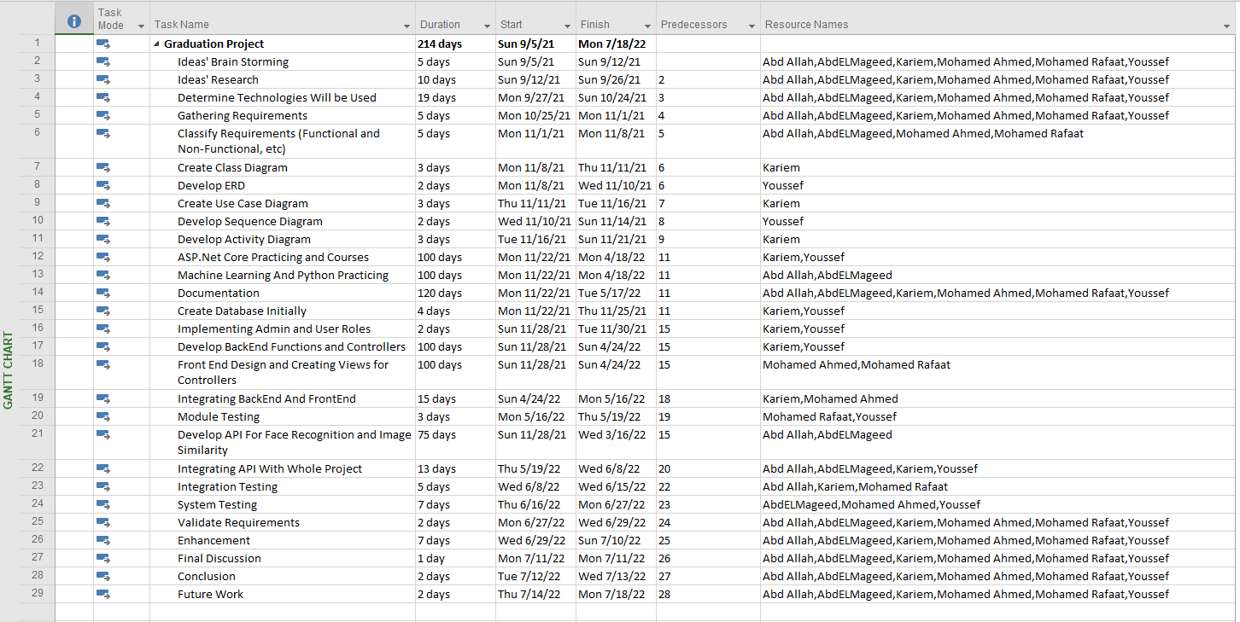Task Sheet:

****



* 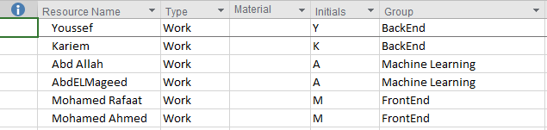Resource Sheet:
* Gantt Chart:

****

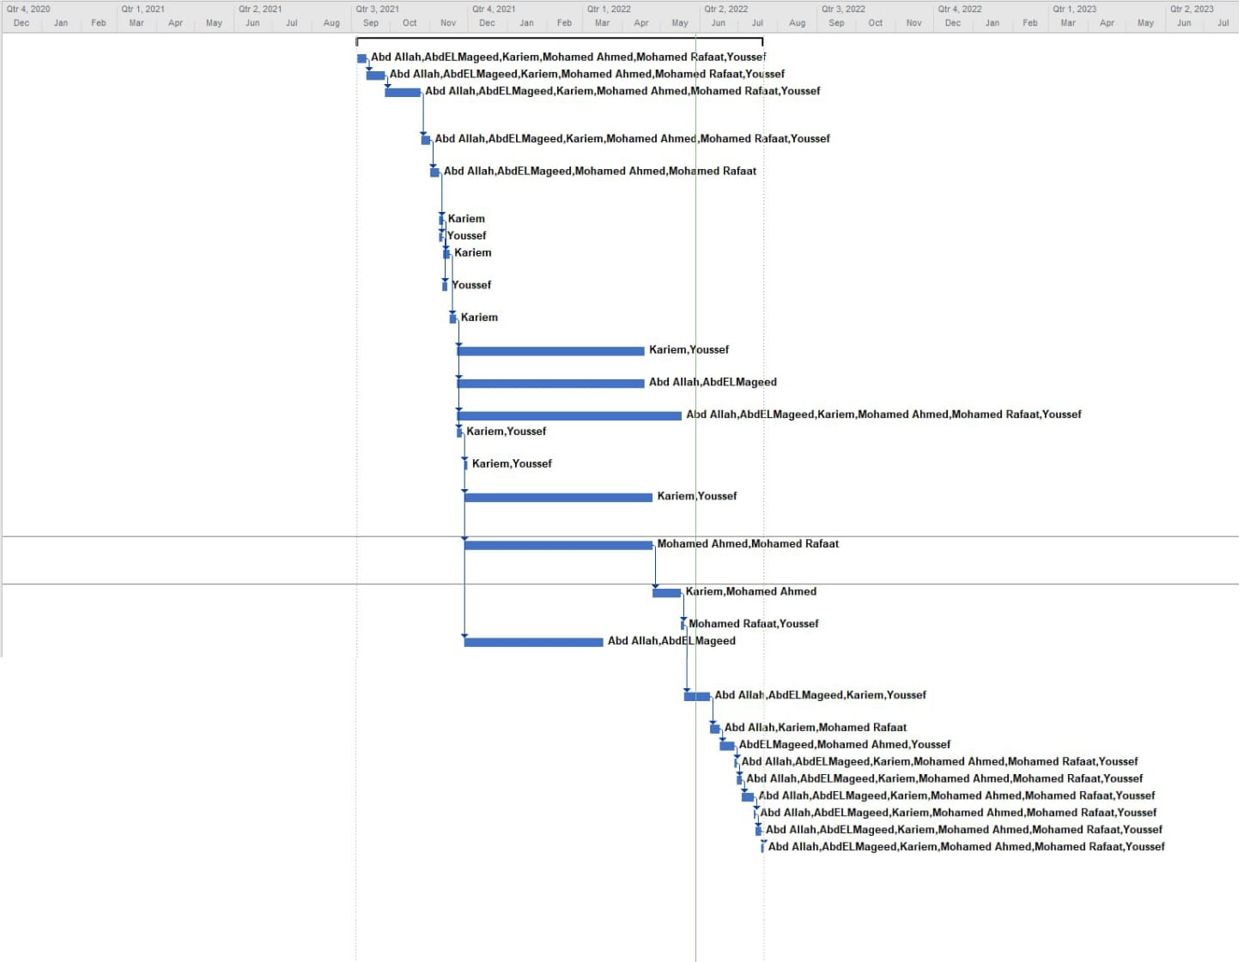

* 1. **Analysis and limitations of existing system:**

|  |  |  |  |  |  |  |
| --- | --- | --- | --- | --- | --- | --- |
| # | App Logo | App Name | Specified for one item | Organized | Duplication | subscription |
| 1 | **F:\Graduation Project\Screenshot 2022-06-01 020243.png** | **Petco Love lost** | **T** | **T** | **T** | **F** |
| 2 | **F:\Graduation Project\Screenshot 2022-06-01 023034.png** | **Lostings** | **F** | **F** | **T** | **T** |
| 3 | **F:\Graduation Project\download.jfif** | **Facebook-groups** | **F** | **F** | **T** | **F** |
| 4 | **F:\Graduation Project\PicsArt_11-06-04.07.36.png** | **Find-Me** | **F** | **T** | **F** | **F** |

****



1. **Petco Love Lost**

* Description:
* Petco Love Lost is a specified web application that helps people to reunite with their lost pets. People can create post.
* It also includes care services for pets.

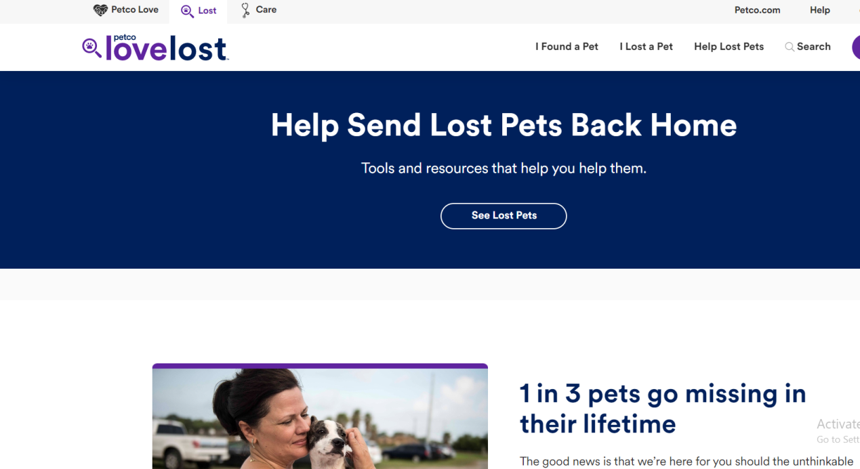

* Limitations:
* This app is limited for only specific countries (America, Canada, and Australia).
* This app is specified for pets only.
* This app allows duplicate and replicated posts.

****



1. **Lostings**

* Description:
* 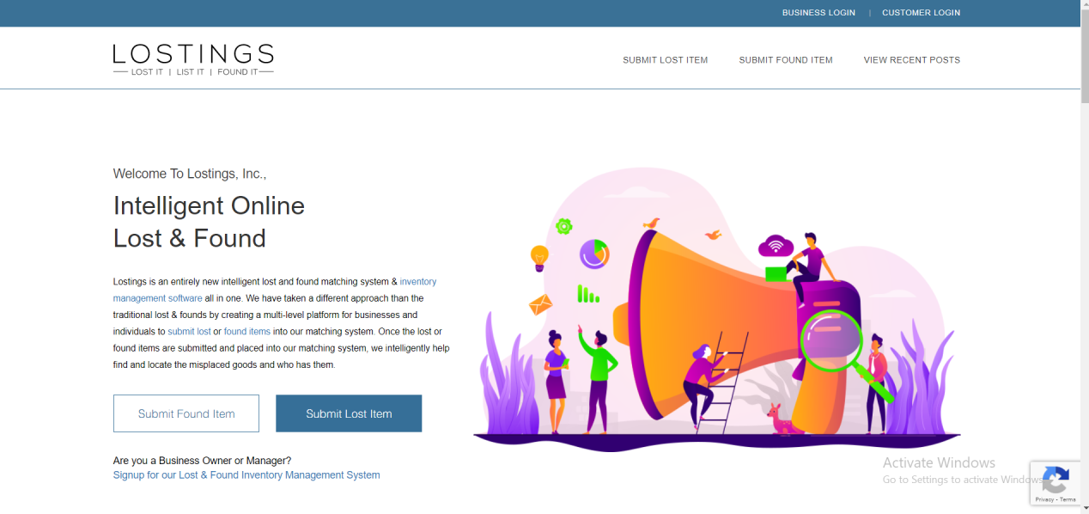Lostings is a web application that helps people finds things they have lost. Where, people can create posts and view recent posts.
* Limitations:
* This application requires monthly subscription.
* Posts are not categorized which makes the search process difficult.
* There is an additional cost for intelligent matching.

****



1. **Facebook-Groups**

* Description:
* There are millions of Facebook groups created on the application to help people finds things they have lost (mobile phones, pets, identity cards, and so on).

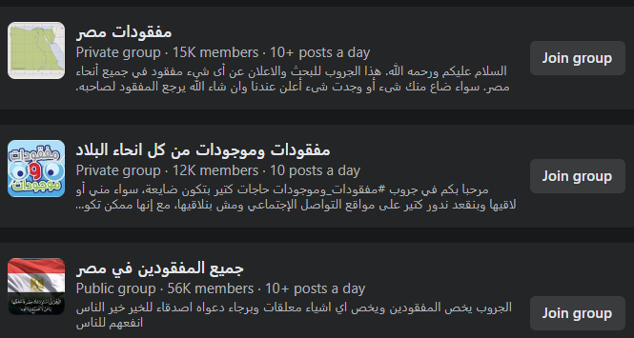

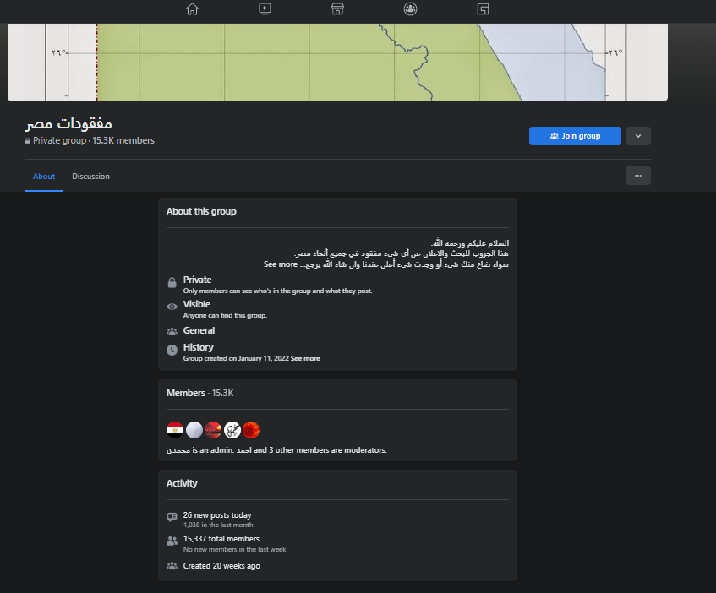

* Limitations:
* ****Some groups are private groups where you have to wait for admin confirm your request to join the group.



* Posts in Facebook groups are not categorized or organized which makes it difficult to search for a specific post.

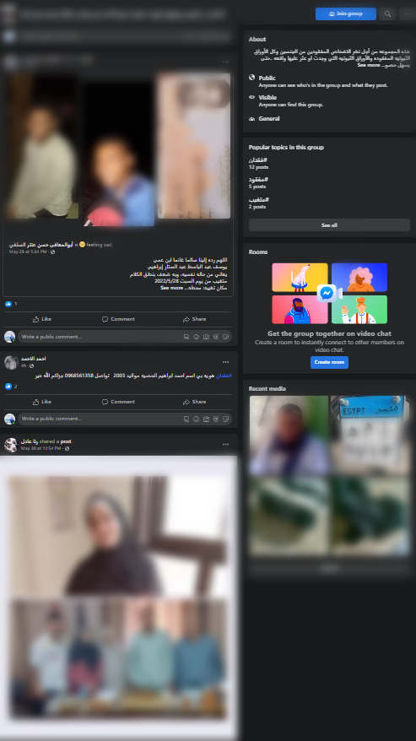

* Facebook groups allow duplicate posts and there is no control over posts where some posts may contain inappropriate images or words.

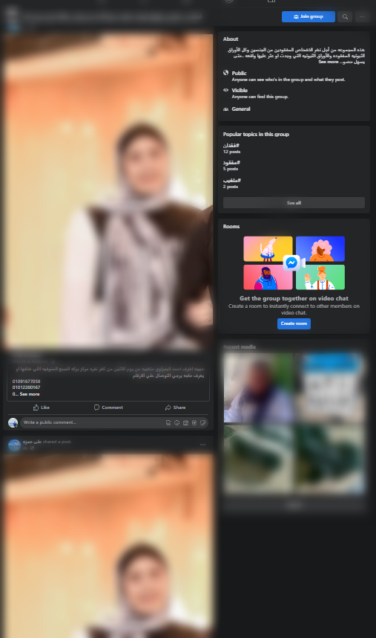

****



1. **Find-Me Mobile Application**

* Description:
* “Find-Me” Web Application is a solution that intends to combine all features of the previous applications.
* People could sign-up to the website without subscription, you have to provide a valid email only and other information (username, phone number, address, Zip Code, etc.).
* People could create post and being posted on the home page in real-time.
* Inappropriate posts will be deleted instantly.
* Posts on home page are categorized and organized.
* User can add comments on any post.
* User can view details of any post on the homepage.
* User can Search for posts created by specific user (by entering his/her username, email, or phone number).
* Users can upload an image and compare images of posts on the homepage and retrieve the post that includes most likely similar image to the uploaded one.

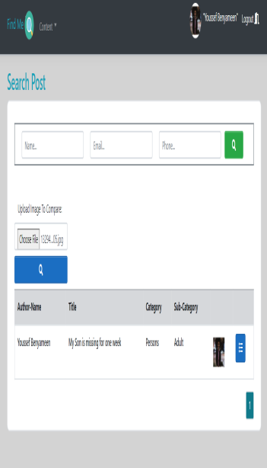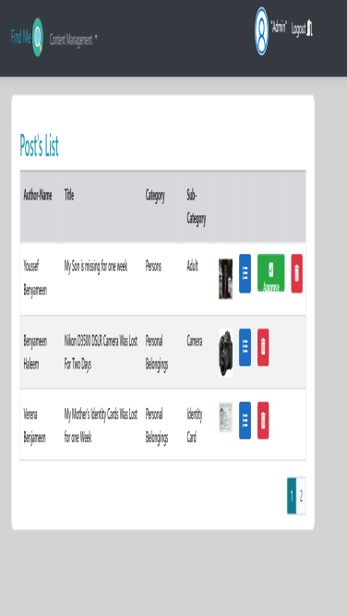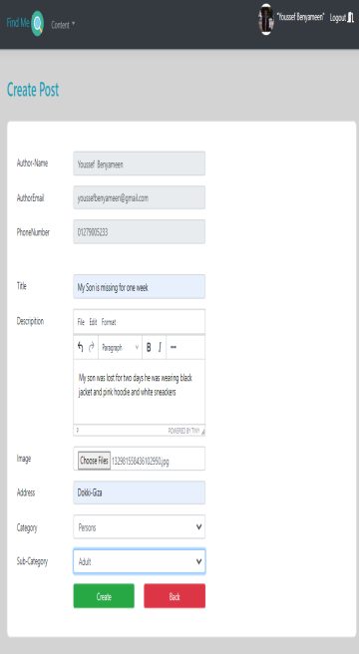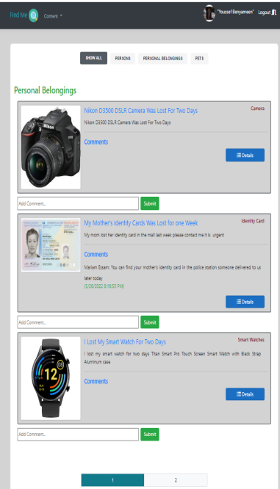

****



* 1. **Need for the new system:**
* This Program solves a daily social problem in all societies. It is the problem of losing something, kidnapping and thefting.
* Every day we hear in the new and see articles in magazines and newspaper and millions of posts on social media about someone being kidnapped or lost, someone has lost something such as mobile phone, his/her wallet, etc.
* So, We created this application to solve these problems:
* Helping people to find their missing children or parents, and also helping people to make a report on their lost or stolen personal belongings in an easy and fast way.
* The application is user friendly and easy to interact with it. Anyone can create post and be submitted on Home Page using only a valid email address.
* People don’t have to pay for subscription to sign up for the website or to create and search for a post.
* A new, innovative, and efficient technology to search for Posts (Face Recognition and Image Similarity).
* The search results are accurate and efficient.
* People can interact with each other easily by adding comments on any posts.

****



* 1. **Analysis of the new system:**
     1. **User Requirements:**
* **Mandatory Requirements:**
* The user can create post, add comment, edit profile, and search for post and receive accurate and precise results similar to his/her request in real-time.
* **Desirable Requirements:**
* The user would be able to use the web application at anytime and anywhere and the application also should be available whenever the user needs it.
* The search results must be accurate and identical as desired by the customer.
* The application should be free of duplicate and replicated posts, also posts should be accurately monitored and controlled by admins to reject and remove inappropriate posts.
  + 1. **System Requirements:**
* The system should be well documented.
* The system should be portable and adapt to other environments.

****

****

* The system should provide means to protect user’s information from disclosure.
* The system shouldn’t accept the inappropriate posts and comments.
* The system should be secure and user’s information is not vulnerable and accessed by others.
* The System should lock user account after five invalid login attempts or adding inappropriate post or comment.
* The system should allow users to register by using Facebook or Google Account.
  + 1. **Domain Requirements:**
* Multiple users must be able to use the application simultaneously without corrupting the database (whatever form it may be).
* The database should be backed up periodically in a while in case the original one does become corrupt.
* The application must validate all values before making the change in the database.

****

* ****The application must have update capabilities for future models.
* The system should lock inactive and spam accounts to prevent overloading that would cause system failure.
* The system should provide external registration such as Facebook or Google.
* The system should make the admin approve the posts before being posted to prevent duplicate and trivial posts.
  + 1. **Functional Requirements:**
* System must contain Sign-Up functionality.
* System must contain External Sign-Up functionality.
* System must contain Log-in functionality.
* System must contain Add Category functionality.
* System must contain Edit Category functionality.

****

* System must contain Delete Category functionality.
* ****System must contain Add Sub-Category functionality.
* System must contain Edit Sub-Category functionality.
* System must contain Delete Sub-Category functionality.
* System must contain Lock-User Account functionality.
* System must contain Unlock-User Account functionality.
* System must contain Approve Post functionality.
* System must contain Reject Post functionality.
* System must contain Founded Post functionality.
* System must contain view users list functionality.
* ****System must contain view post list functionality.
* ****System must contain add comment functionality.
* System must contain view details of post functionality.
* System must contain create post functionality.
* System must contain edit post functionality.
* System must contain delete post functionality.
* System must contain search name functionality.
* System must contain search email functionality.
* System must contain search phone number functionality.
* System must contain search using image functionality.

****



* + 1. **Non-Functional Requirements:**
* **Availability:**

Our application can be used in any time and it always “uptime” is the amount of time that it is operational and available for use. This is specified because some systems are designed with expected downtime for activities like database upgrades and backups.

* **Efficiency:**

Our application utilized highly efficient resources such as, CPU cycles, disk space, memory, bandwidth, etc.

* **Flexibility:**

If the team intends to increase or extend the functionality of the software after it is deployed, that should be planned from the beginning; it influences choices made during the design, development, testing, and deployment of the system.

* **Performance:**

****Our application is specifying the timing characteristics of the software. Certain tasks or features are more time sensitive than others; the non-functional requirements should identify those software functions that have constraints on their performance.



* **Reliability:**

Our application is capable of maintaining its performance over time. Unreliable systems fail frequently, and certain tasks are more sensitive to failure.

* **Robustness:**

Our application is able to handle error conditions elastically, without failure. This includes a tolerance of invalid data, software defects, and unexpected operating conditions.

* **Scalability:**

Our application is scalable as it has the ability to handle a wide variety of system configuration sizes. The Non-Functional requirements should specify the ways in which the system may be expected to scale up (by increasing hardware capacity, adding machines).

* **Usability:**

Our application is easy to use where it address the factors that constitute the capacity of the software to be understood, learned, and used by its intended users.

****



* 1. **Advantages of the new system:**
* “Find-Me” Application works anytime and using any browser.
* “Find-Me” Application does not require subscription fee to register to the website and use its features, all you need is just a valid email address.
* Posts are highly controlled and managed; there are no duplicated, redundant or inappropriate posts.
* Posts are submitted and created in real time for urgent cases.
* AI Feature (Face Recognition) to retrieve post similar to the user input and to facilitate the search process.
* User’s information is highly secured and integrated from unauthorized access.
* Web interface is user-friendly and easy to be used by any intended user.

****

****

* 1. **Risk and Risk Management:**
* **Risk Management Process:**

1. Risk identification:

|  |  |
| --- | --- |
| Risk Type | Possible Risks |
| Technology | The IIS Express used in the system to host the web application cannot process as many transactions per second as expected. The System may fail or cannot handle such overload. |
| People | It is impossible to hire staff with the skills required. Key staff may get sick or unavailable at critical times.  Required training for staff is not available. |
| Requirements | Changes to the requirements that require major design rework are proposed.  Customers fail to understand the impact of requirements changes. |
| Estimation | The time required to develop the application is underestimated. The rate of defect repair is underestimated. |



1. Risk Analysis:

|  |  |  |
| --- | --- | --- |
| Risk | Probability | Effects |
| Organizational financial problems force reductions in the project budget | **Low** | **Catastrophic** |
| it is impossible to hire team with the required skills for the project | **High** | **Catastrophic** |
| Key staff are sick or unavailable at critical times in the project | **Moderate** | **Serious** |
| IIS Express used in the system to host web application cannot process as many transactions per second as expected | **Moderate** | **Serious** |
| Changes to the requirements that require major design rework are assumed | **Moderate** | **Serious** |
| Transaction processing is limited | **High** | **Serious** |
| The time required to develop the system is underestimated | **High** | **Serious** |
| Users fails to understand the impact of requirements change | **Moderate** | **Tolerable** |
| our system environment is unstable | **Moderate** | **Serious** |

****



1. Risk Planning:

|  |  |
| --- | --- |
| Risk | Strategy |
| Organizational financial problems | Prepare a briefing document for senior management showing how the project is making a very good contribution to the goals of the business. |
| Recruitment problems | Alert working team of potential difficulties and the impacts of the delay. |
| Staff sickness | Reorganize team so that there is more overlap of work and people, therefore understand and collaborate with each other. |
| Defective components | Replace potentially defective components with bought-in components of known reliability. |
| Requirements change | Derive traceability information to assess requirements change impact, maximize information hiding in the design. |
| ISS Express performance | Investigate the possibility of buying a server with higher performance. |
| Database performance | Investigate the possibility of buying a higher performance database. |

****



**Chapter 3.**

**Software Design**

****In this chapter we’re going to discuss and go deeper in settle web application’s design, and present its diagrams and database.



* 1. 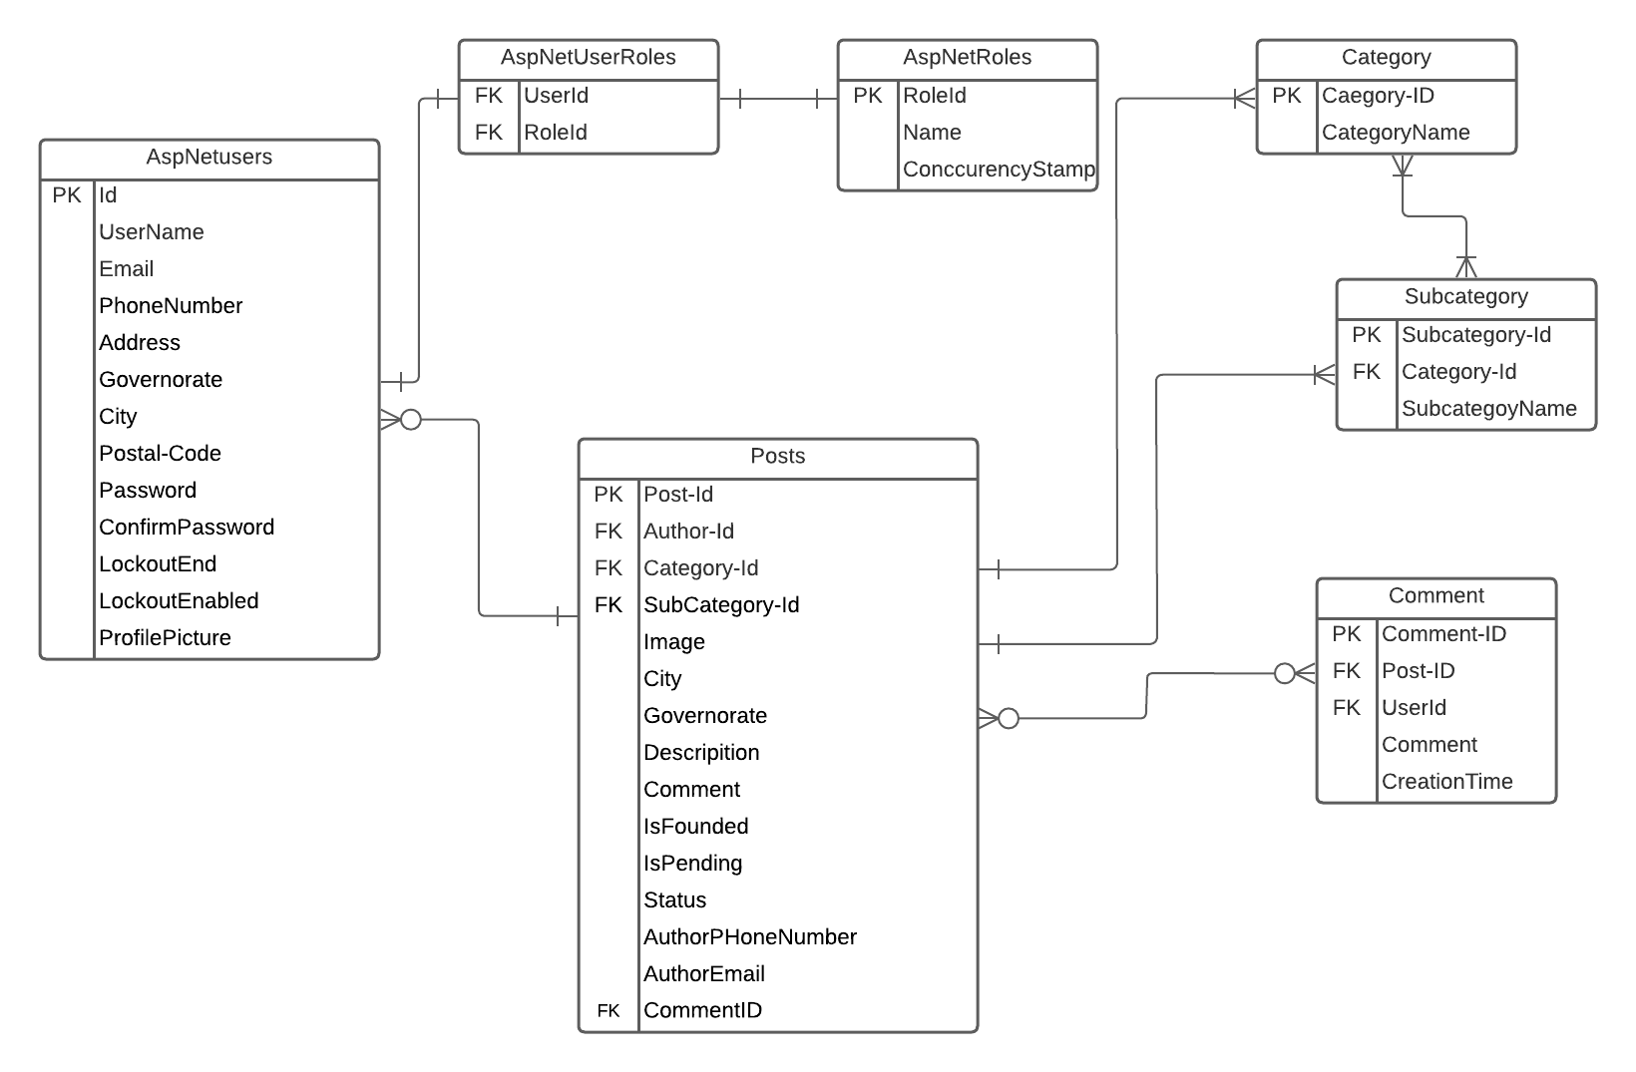**Design of Database (ERD or Class) Diagram:**

****

****

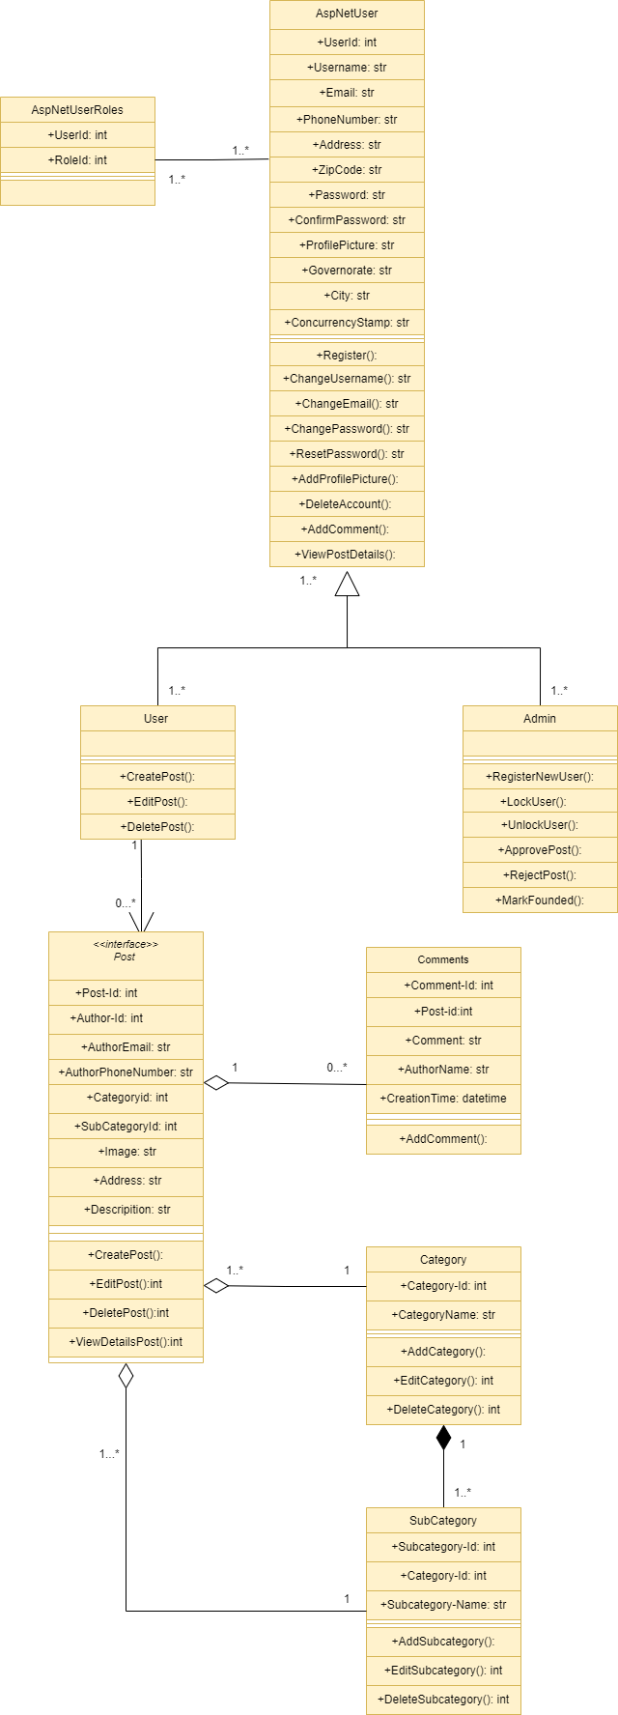

* 1. **Use Case Diagram:**
* **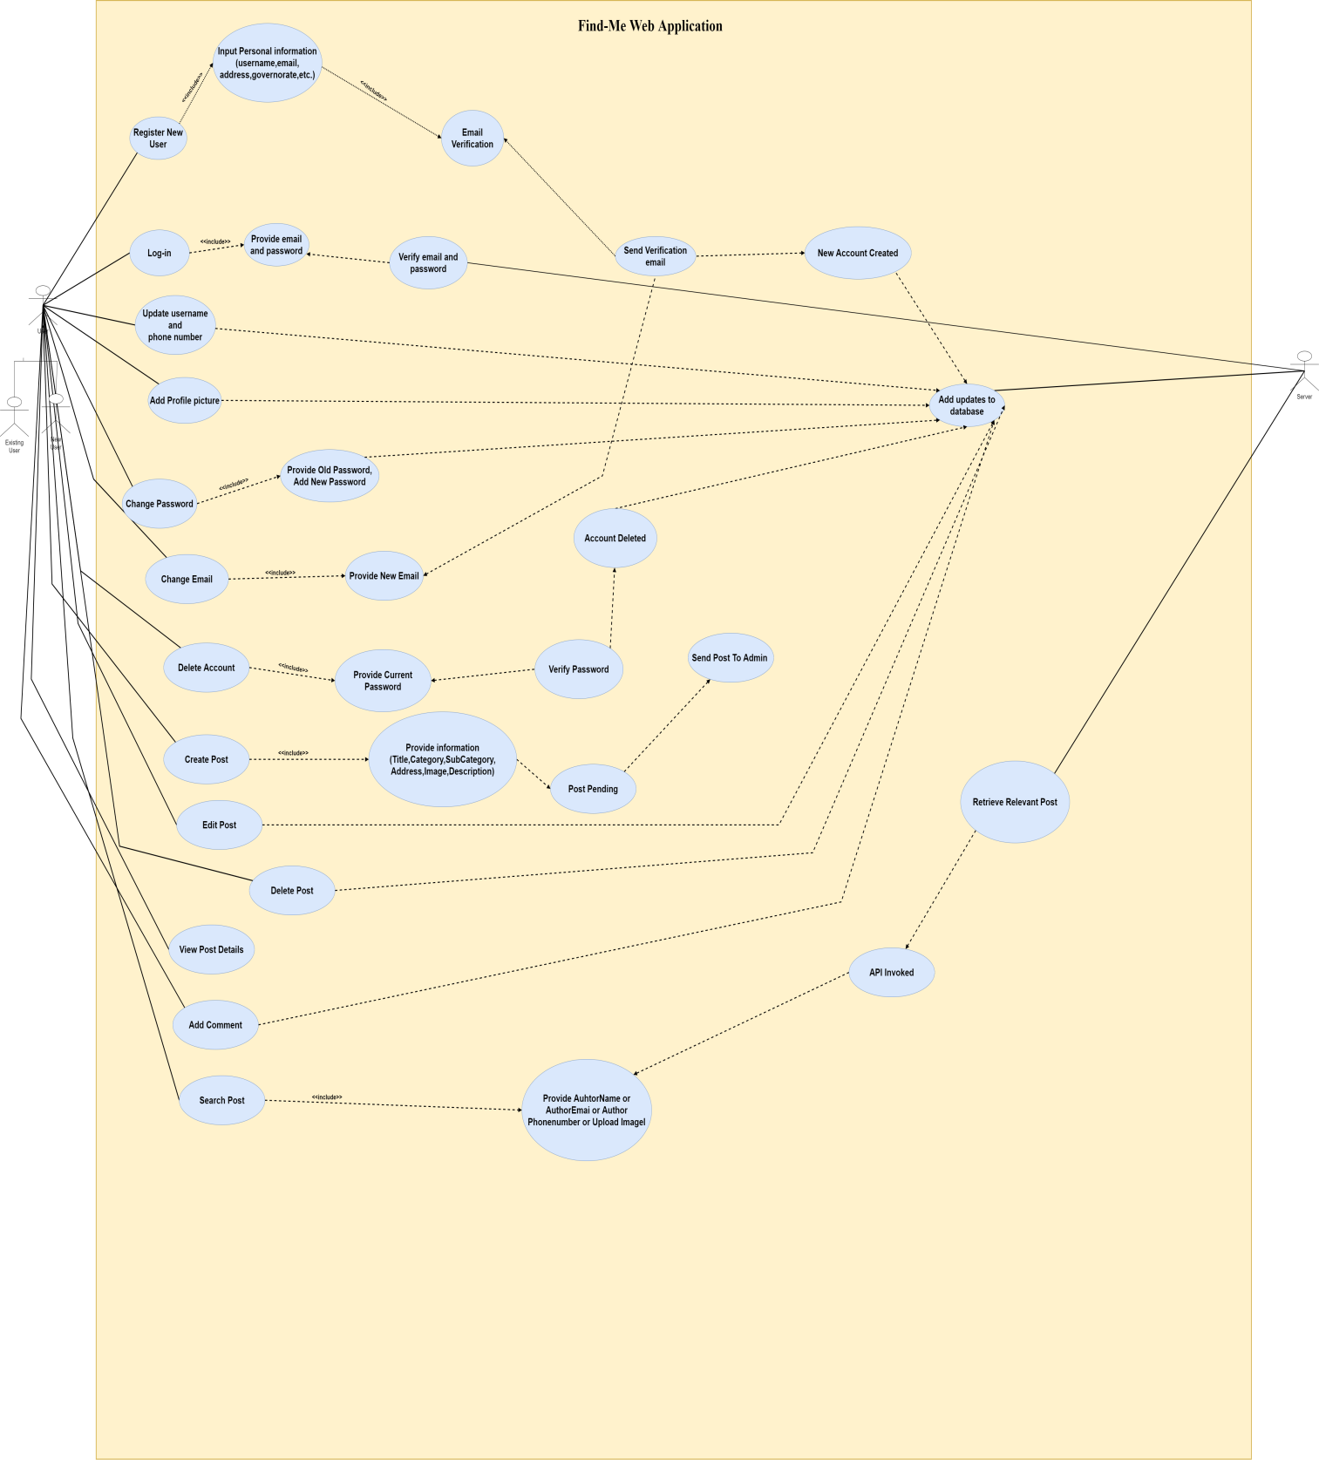User**

****

* **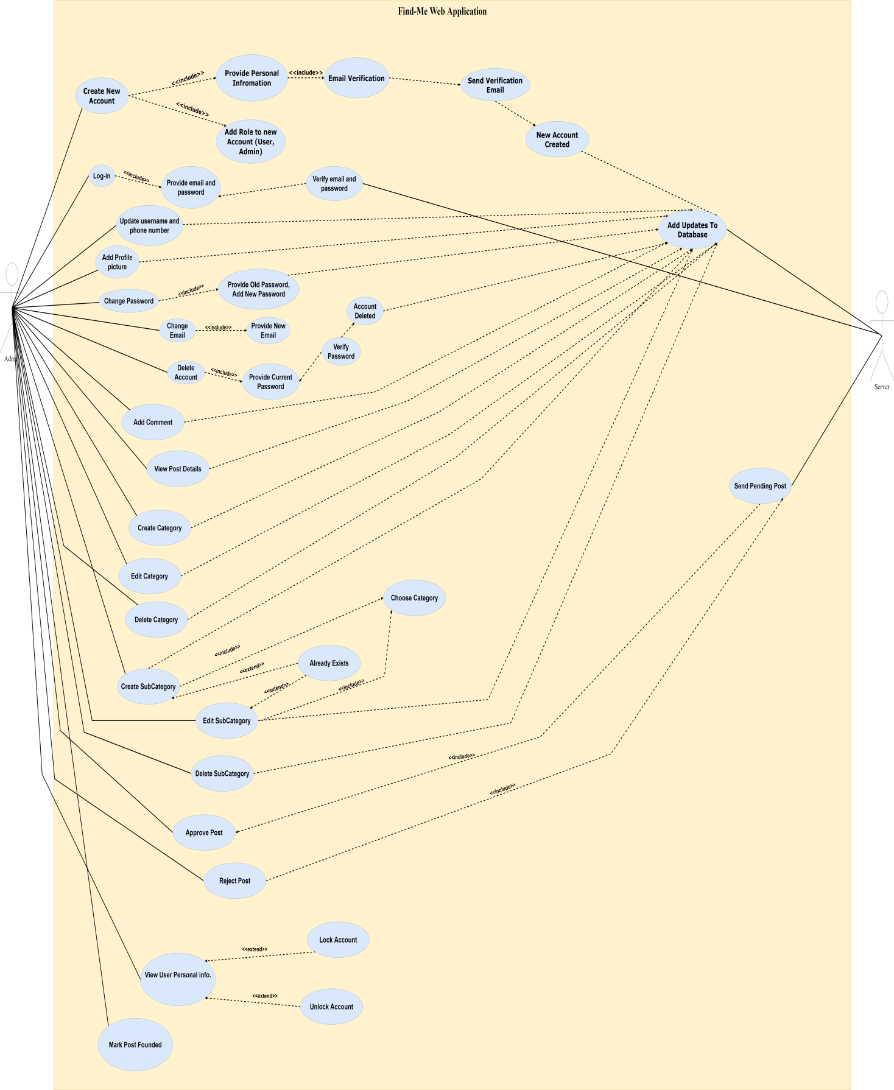Admin**
  1. **Sequence Diagram:**
* **User Registration:**

**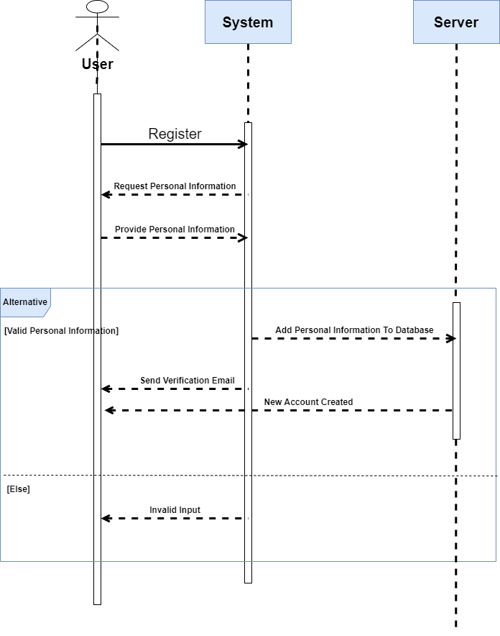**

****



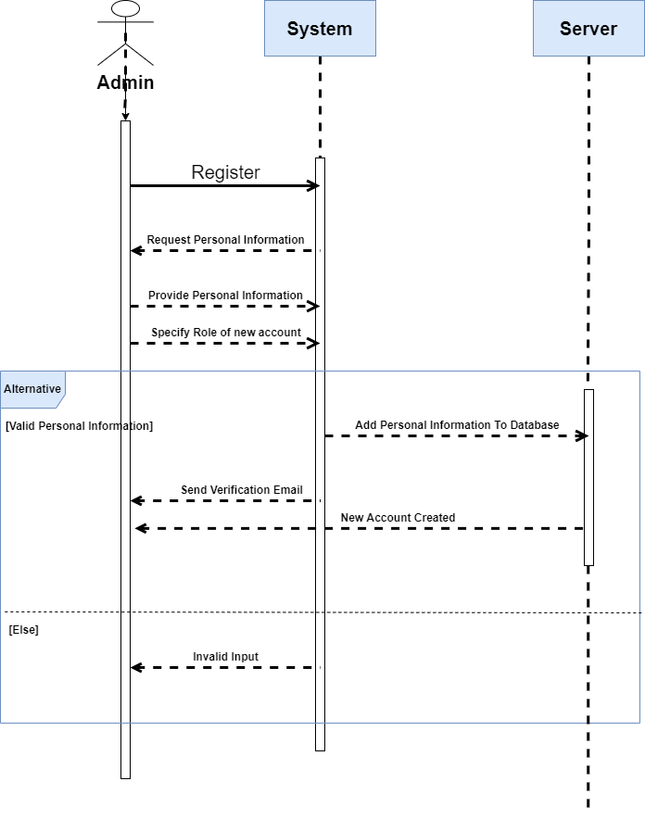

* **Admin Registration:**

****

**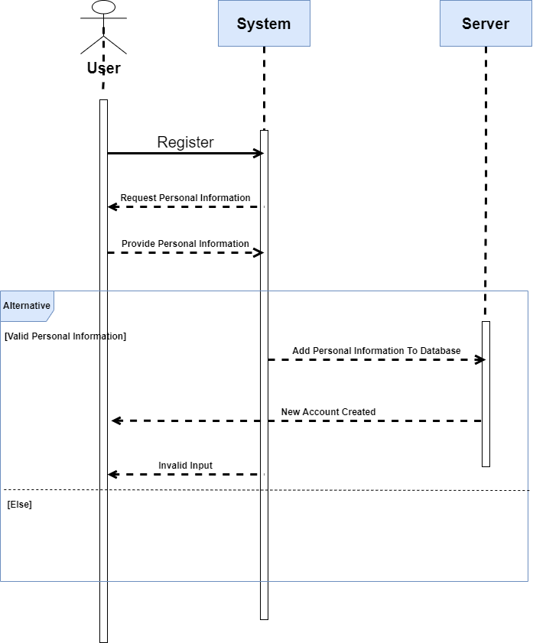**

* **Log-in:**

****

* **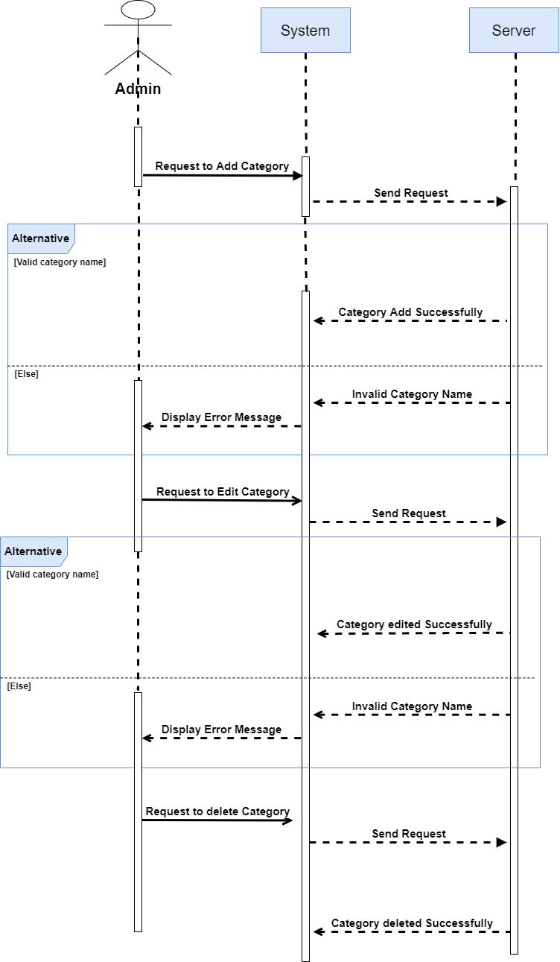****Category:**
* **Sub-Category:**

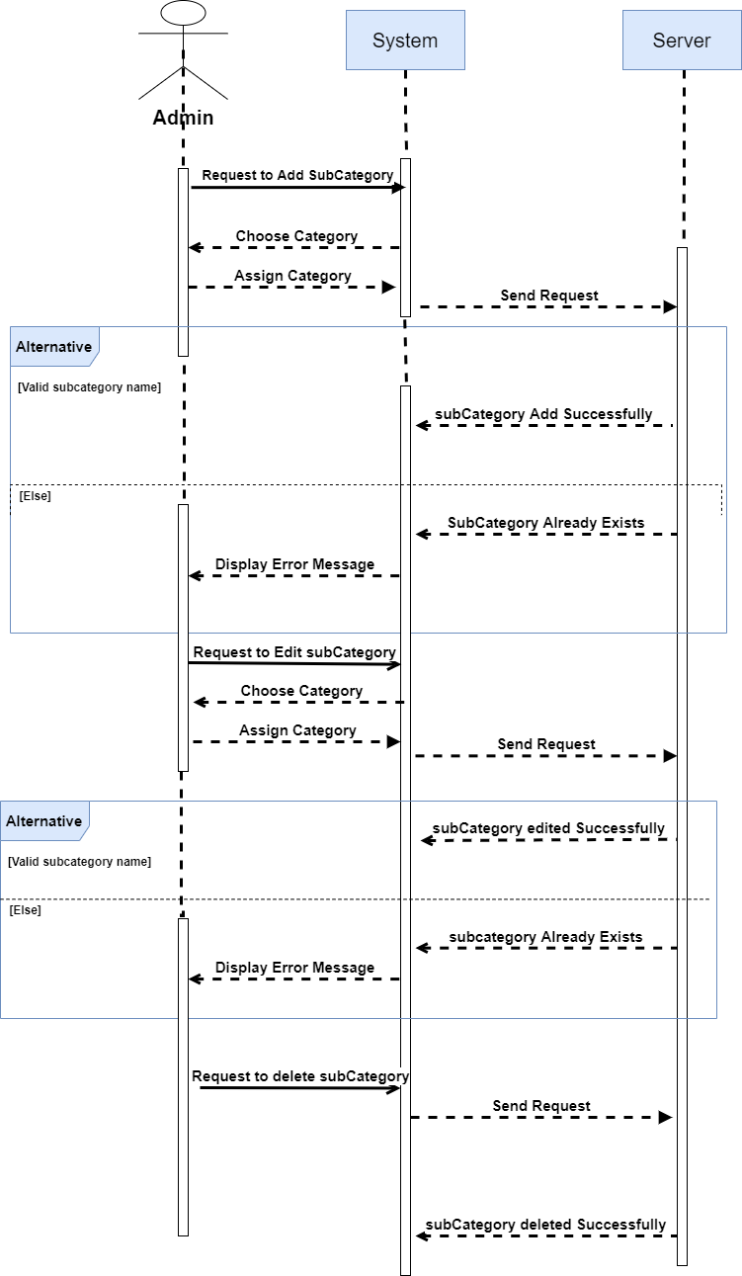

****



* **Profile:**
* 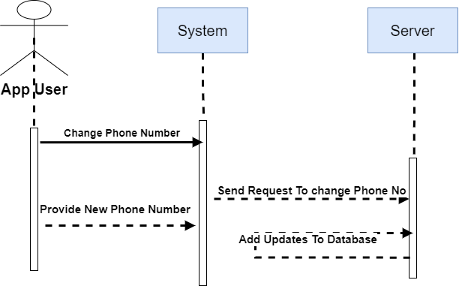**Change Username:**

****



* **Change or Add Profile Picture:**

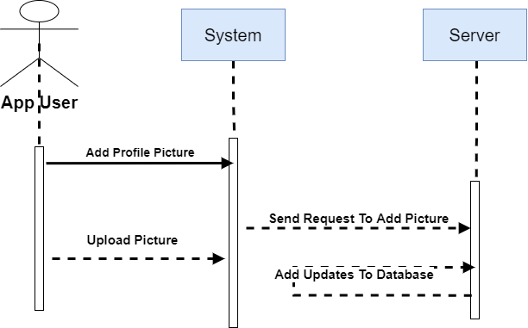

****



* **Change Phone number:**



****



* **Change Email:**

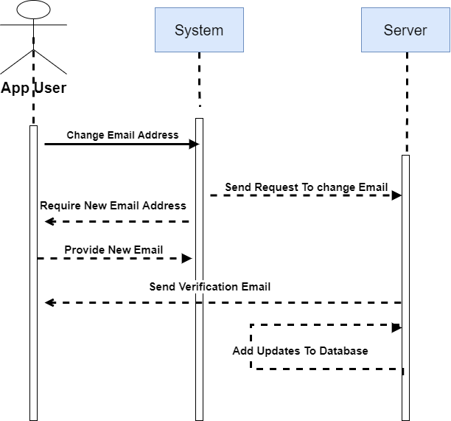

****

**Change Password:**

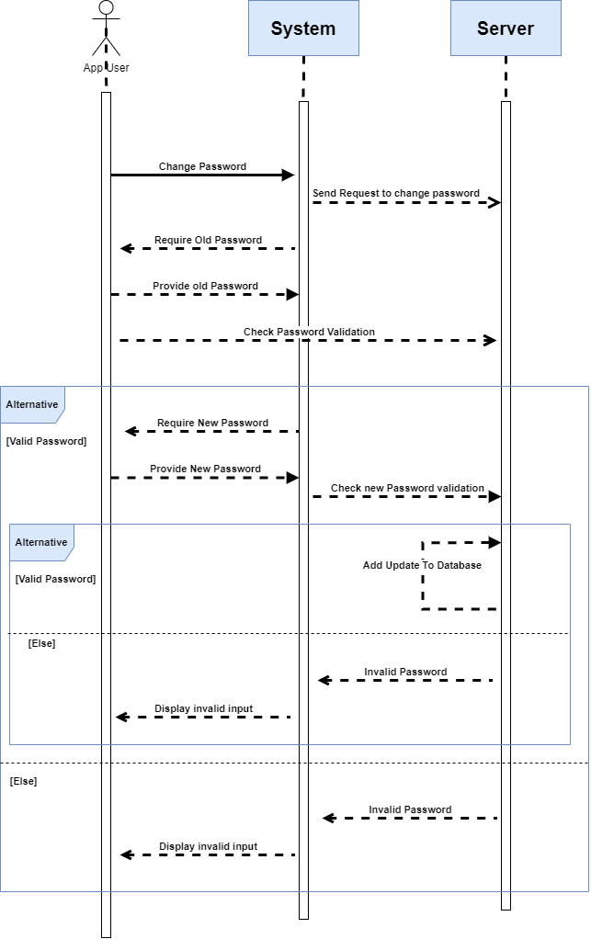

****

* **Delete Account:**

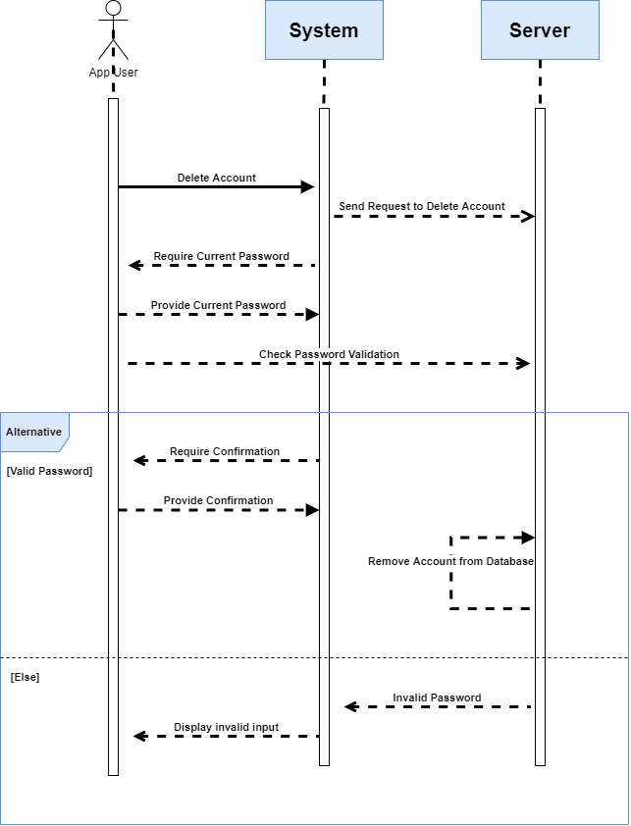

****



* **Manage Users:**

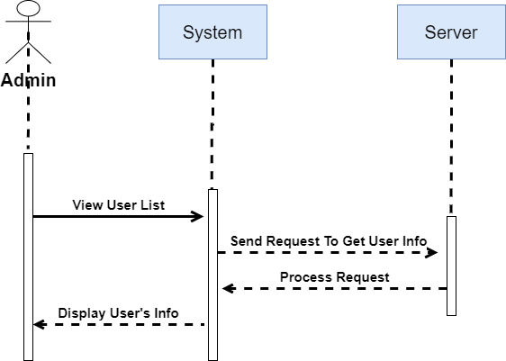

****



* **Lock/Unlock Users:**

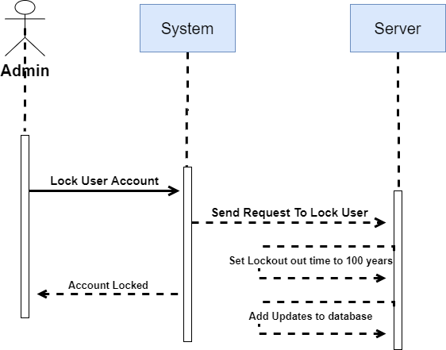

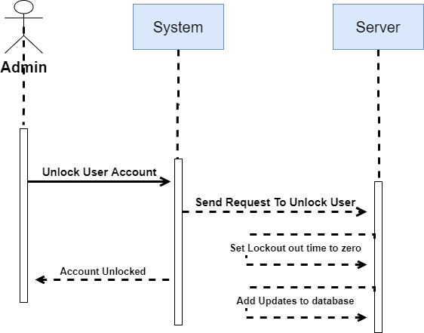

****



* **Approve/Reject Post:**

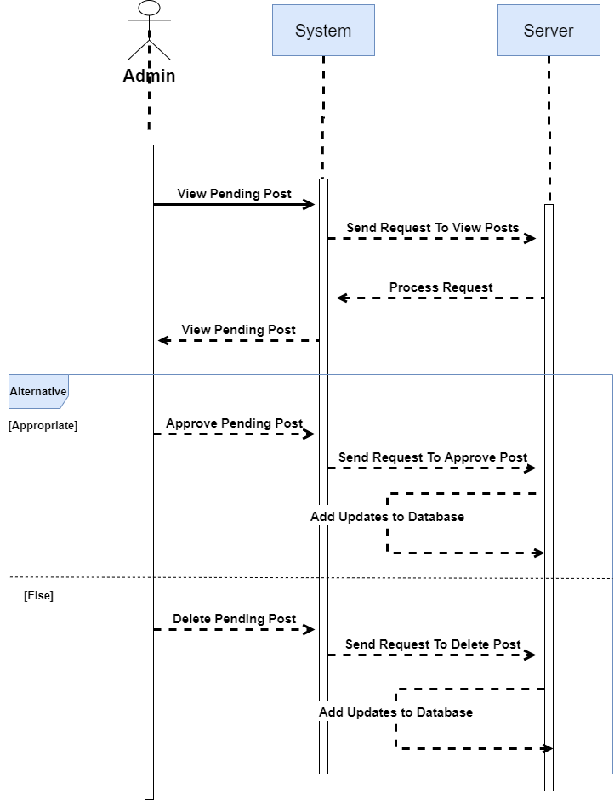

****



* **Found/Unfound Post:**

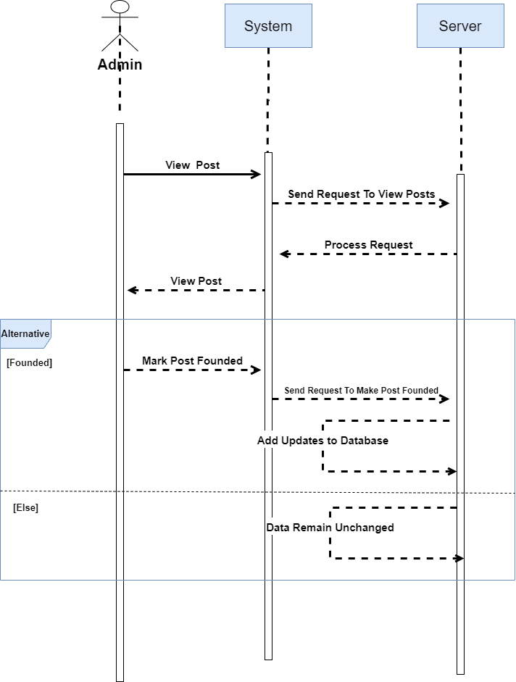

****



* **Create Post:**

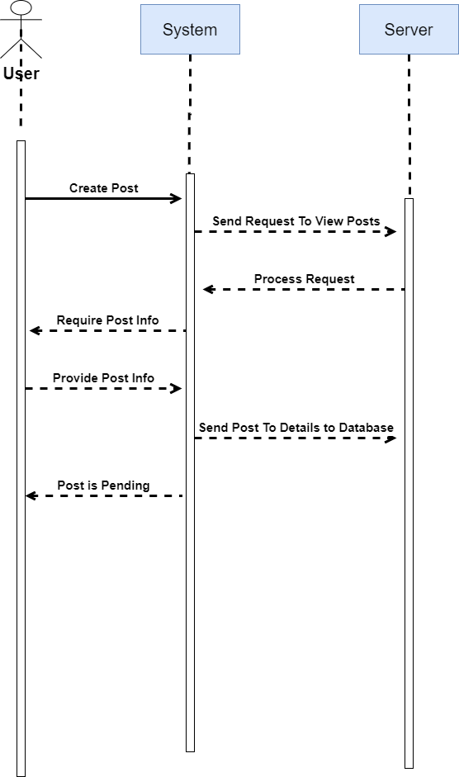

****



* **Edit/Delete Post:**

****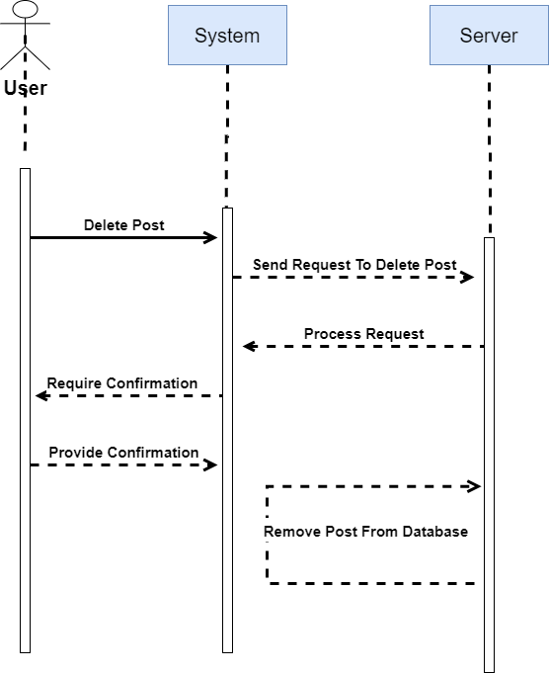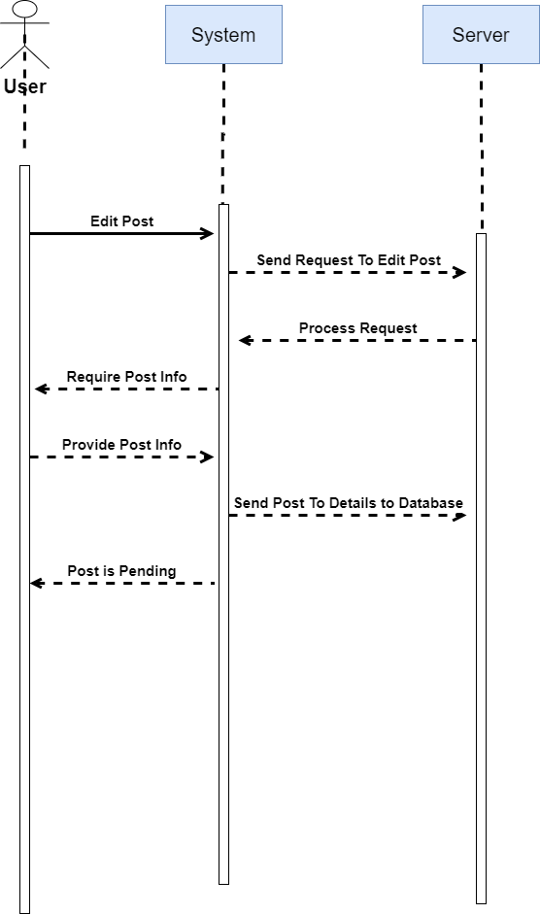



* **Add Comment:**

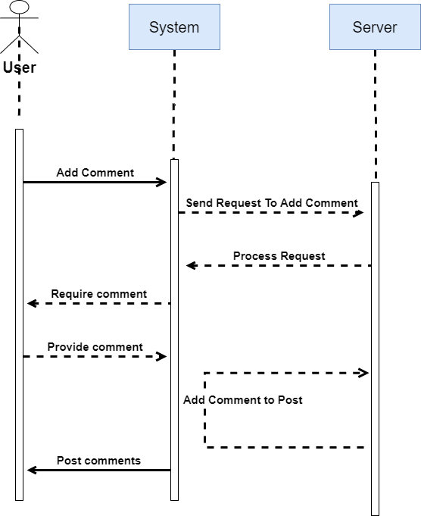

****



* **Search Post:**

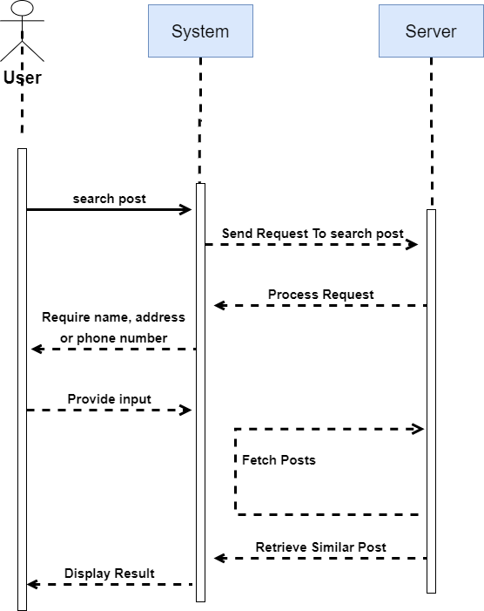

****



* **3.4 Activity Diagram:**
* **Registration:**

**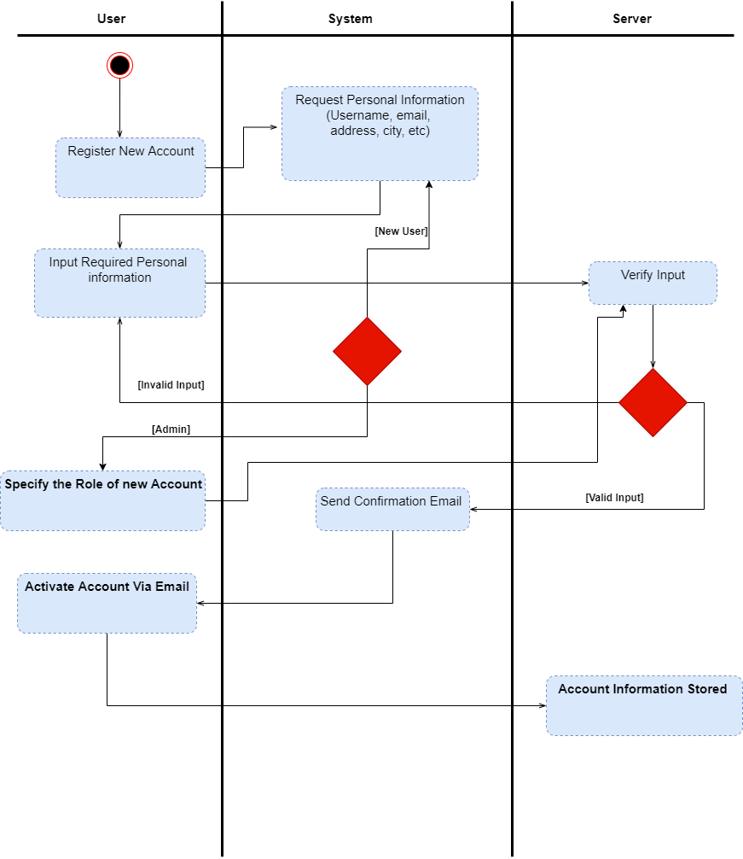**

****

* **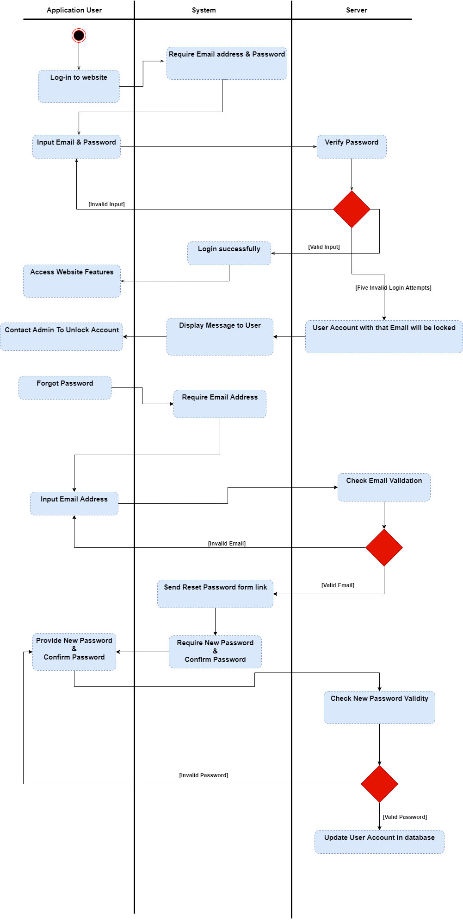****Login:**

****

* **Post:**

**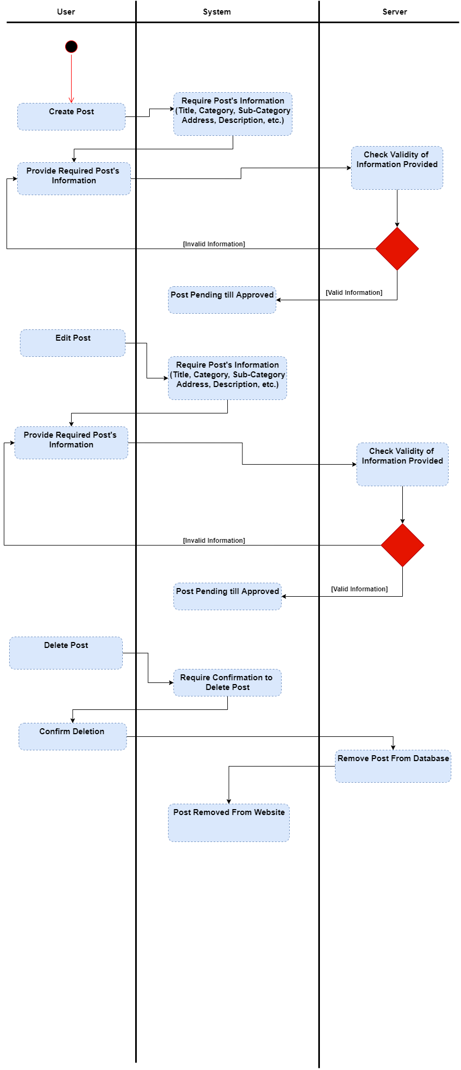**

****

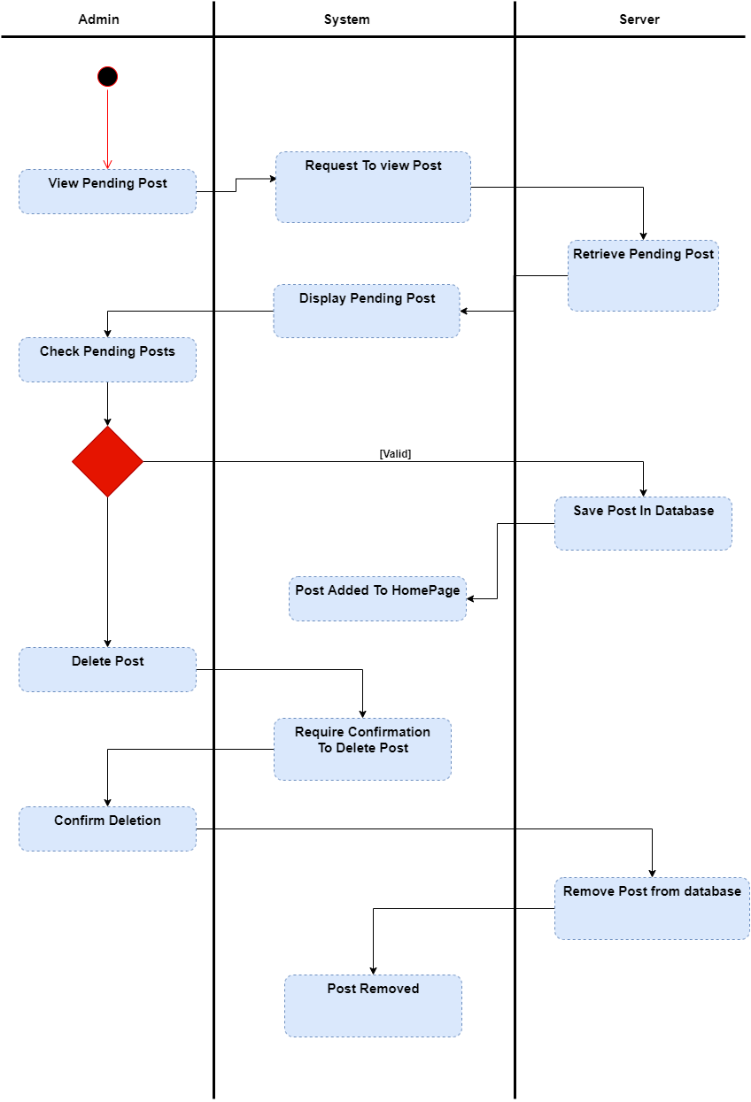

****



* 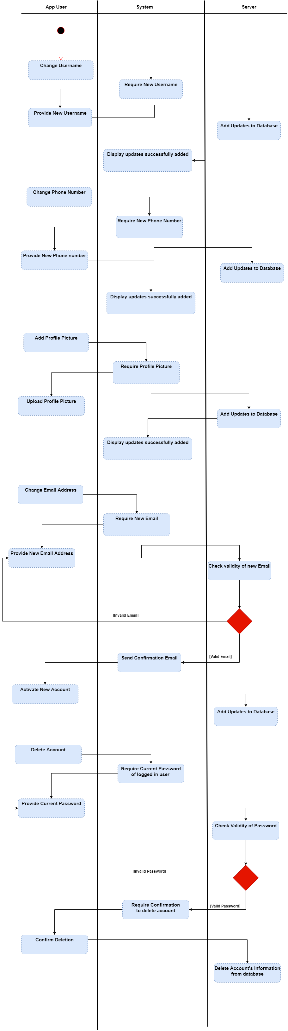**Profile:**

****

* 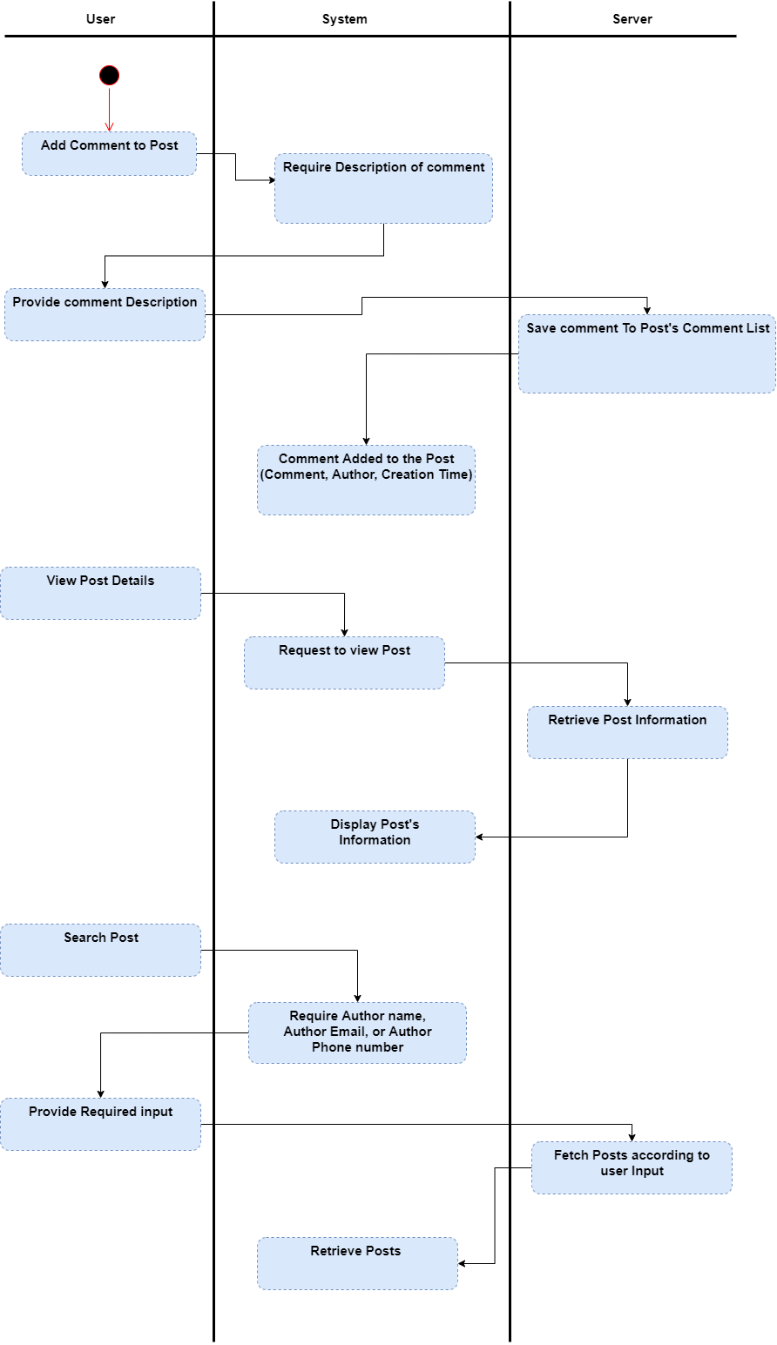**User** **Activities:**



* **Admin Activities:**

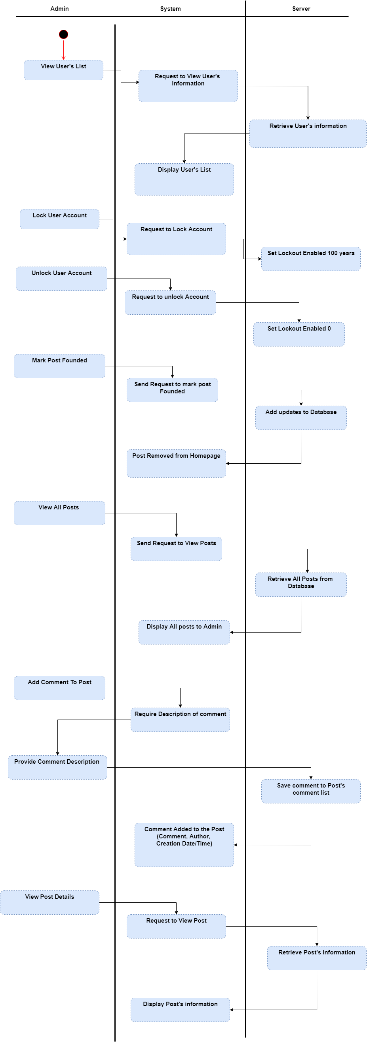

****



**Chapter 4.**

**Project Planning & Analysis**

In this chapter we’re going to discuss and go deeper in settle web application’s implementation, and present its code and the algorithms used to build it.

****

* 1. **Software Architecture:**
* **Application Structure:**

**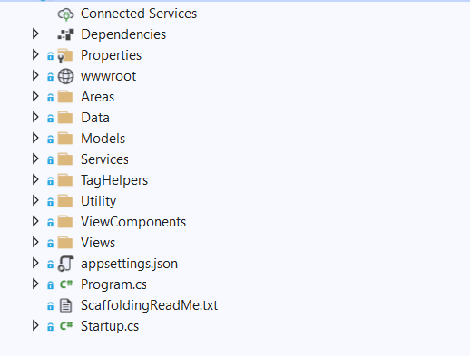**

****



* **Add Category:**

**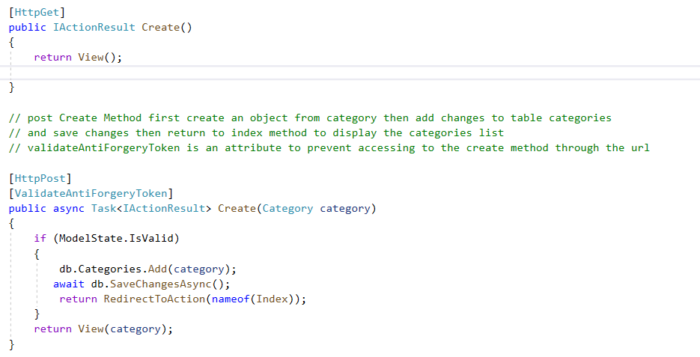**

* **View list of Categories:**

**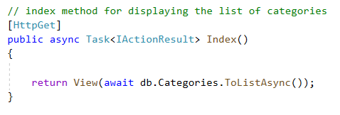**

****

* **Edit Category:**

**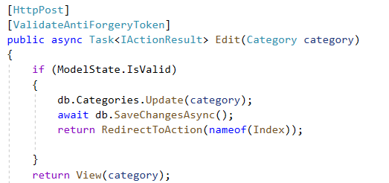**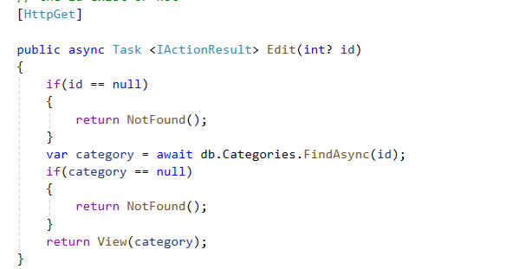



* **Delete Category:**

**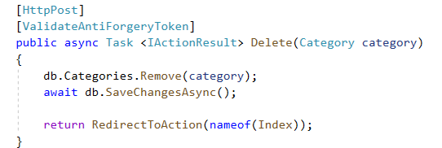**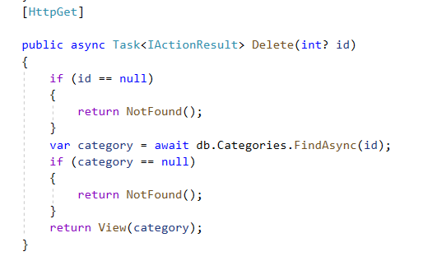

****

* **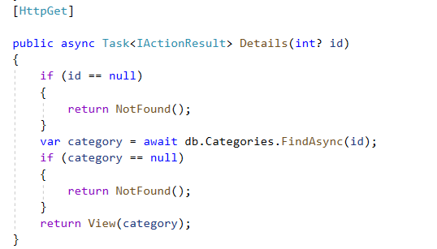 View Details of Category:**

****

****

* **List of Sub-Categories:**

**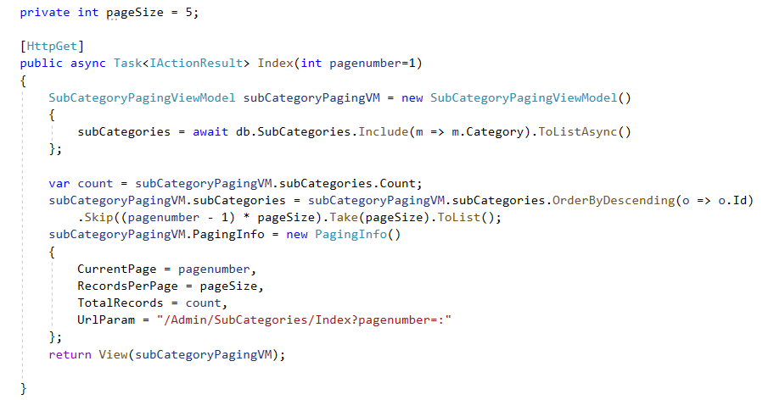**

* ****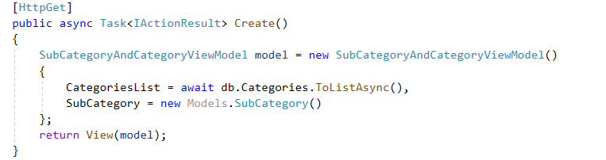 **Create Sub Category:**

**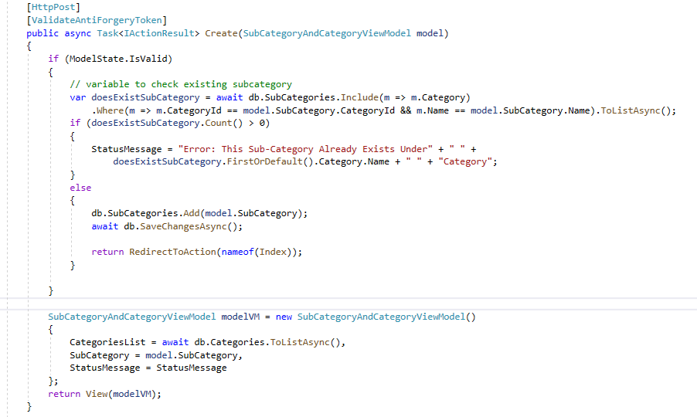**

****

* **Existing Sub-Categories for Chosen Category:**

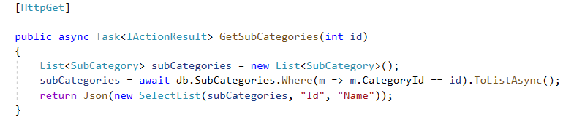

****

* 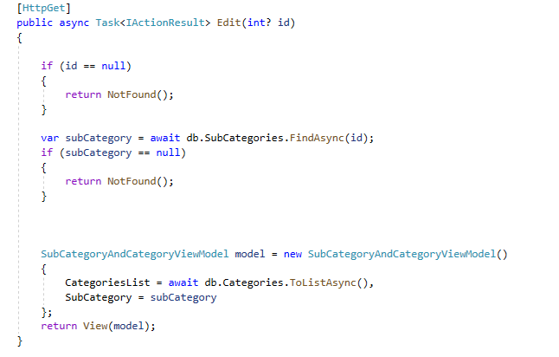** Edit Sub-Category:**

**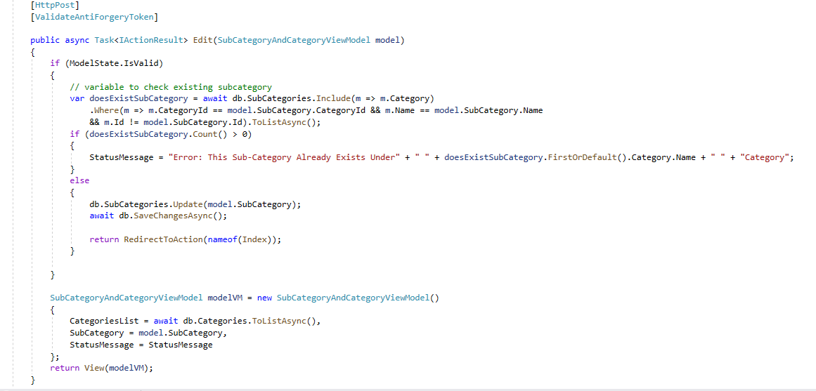**

****

****

* **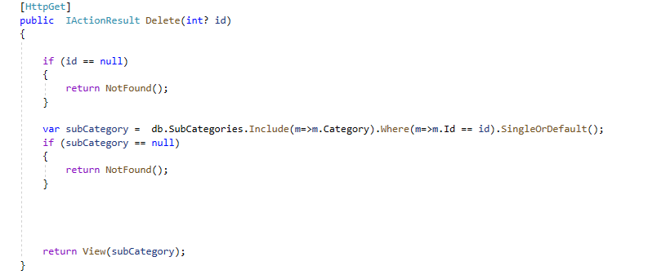Delete Sub-Category:**

**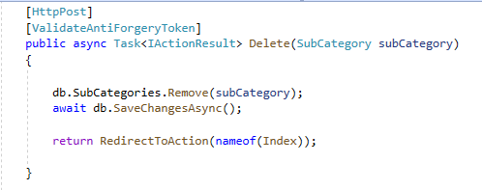**

****

* **View Details of Sub-Category:**

****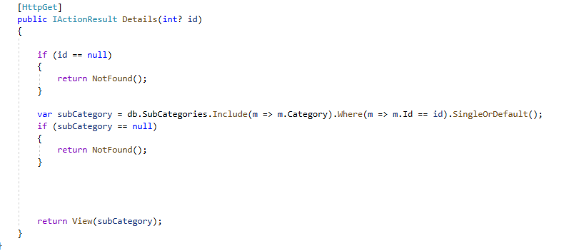

****

* **View List of App-Users:**

****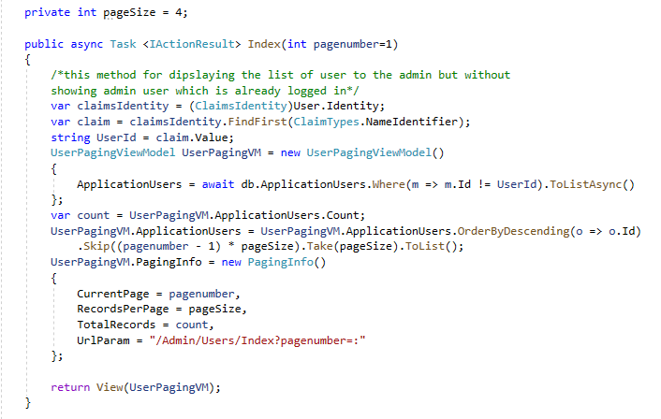

****

* **Lock / Unlock Account:**

****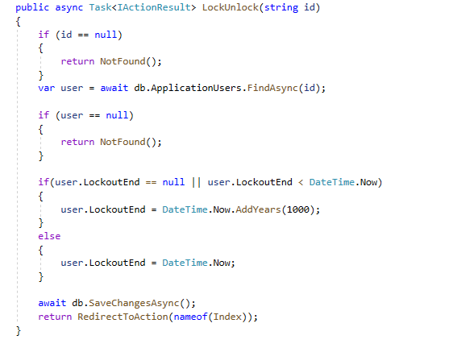

****

* **List Of All Posts:**

**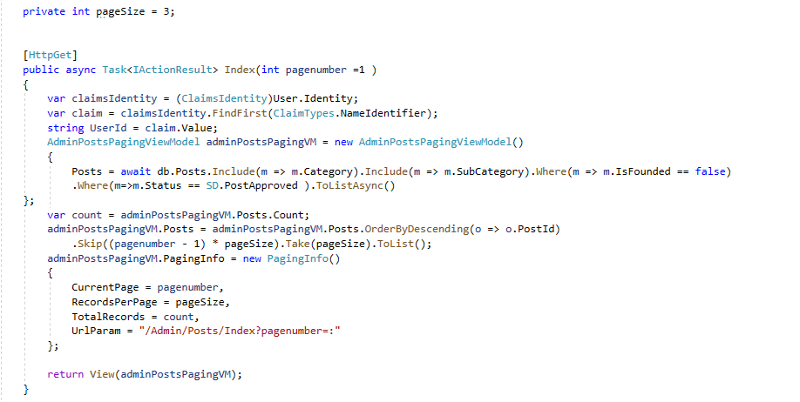**

****

****

* **View Post Details:**

**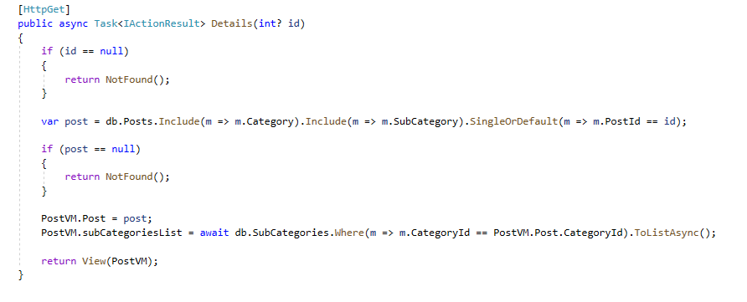**

****

**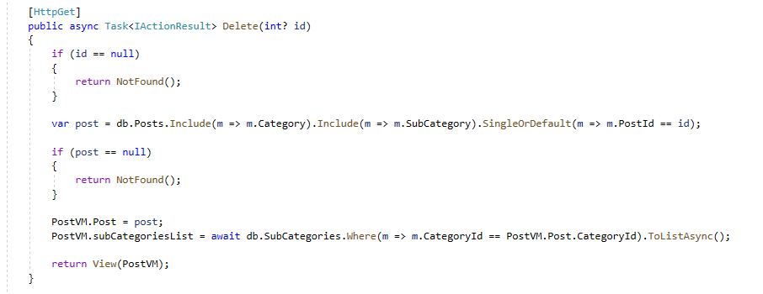**

* **Delete Post:**

**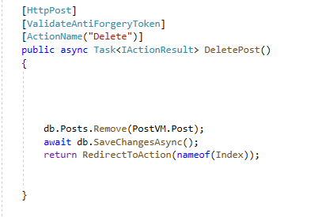**

****

* **List of Pending Posts:**

****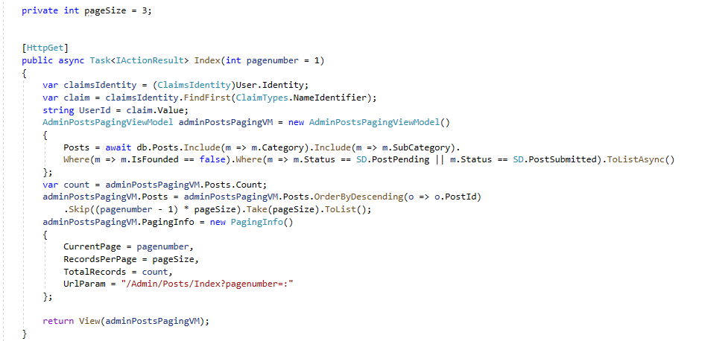

****

* **Submit Posts:**

**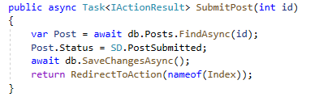**

* **Approve Posts:**

**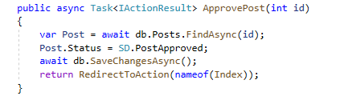**

****

* **View List of Un-Founded Items:**

**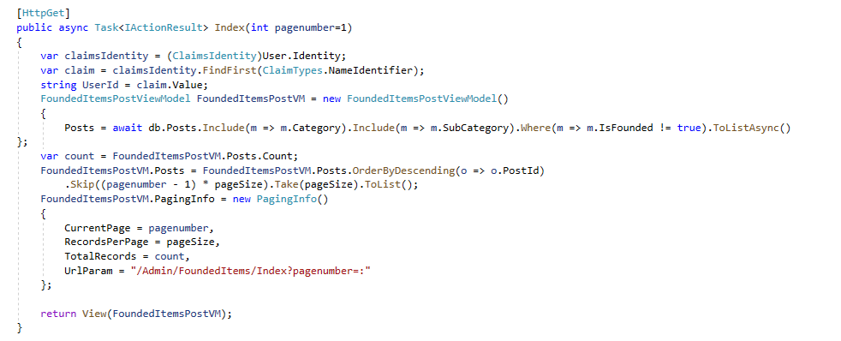**

****

****

* **Mark Post as Founded:**

****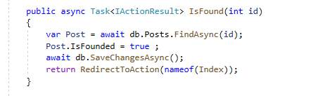

****

* **List of Posts in Home-Page:**

****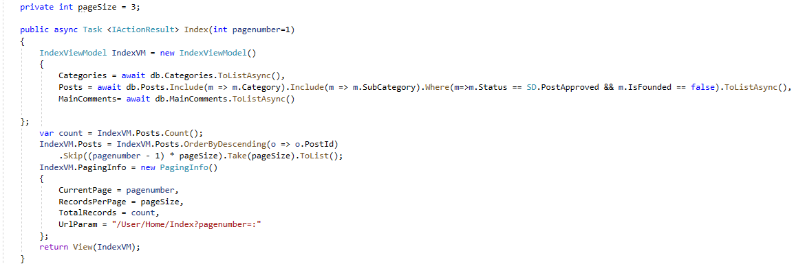

****

* **Add Comment to Post:**

**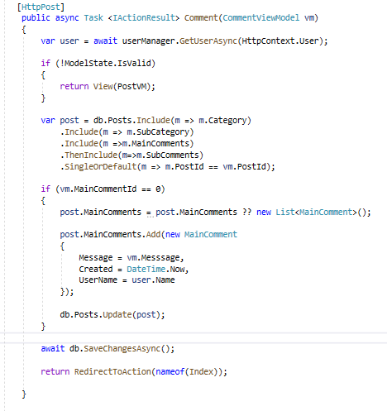**

****

****

* **List of User’s Post:**

**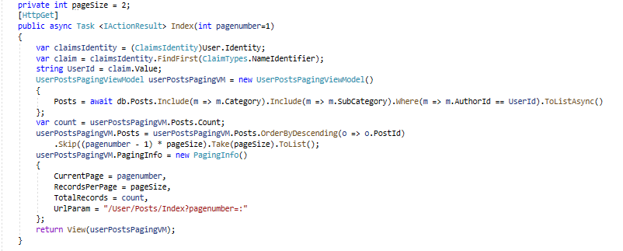**

****

****

* **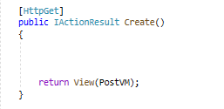Create Post:**

**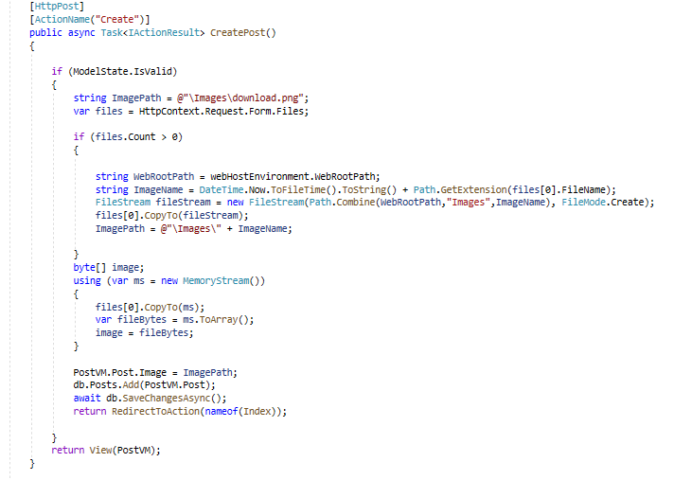**

****

* **Edit Post:**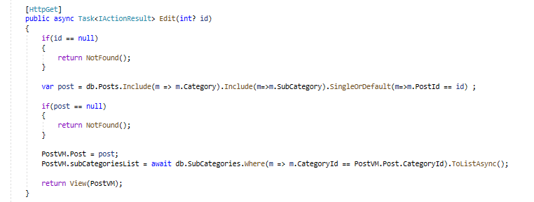

**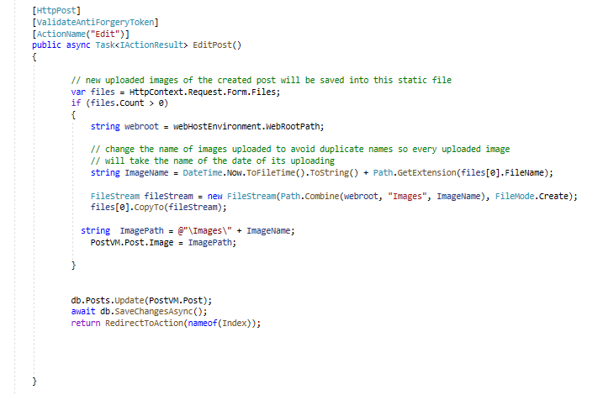**

****

* **View Post Status:**

**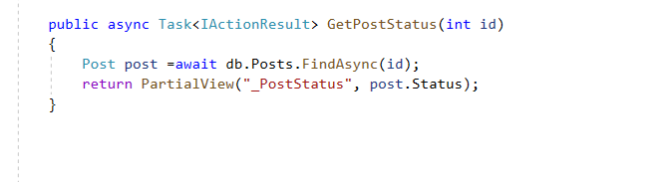**

* **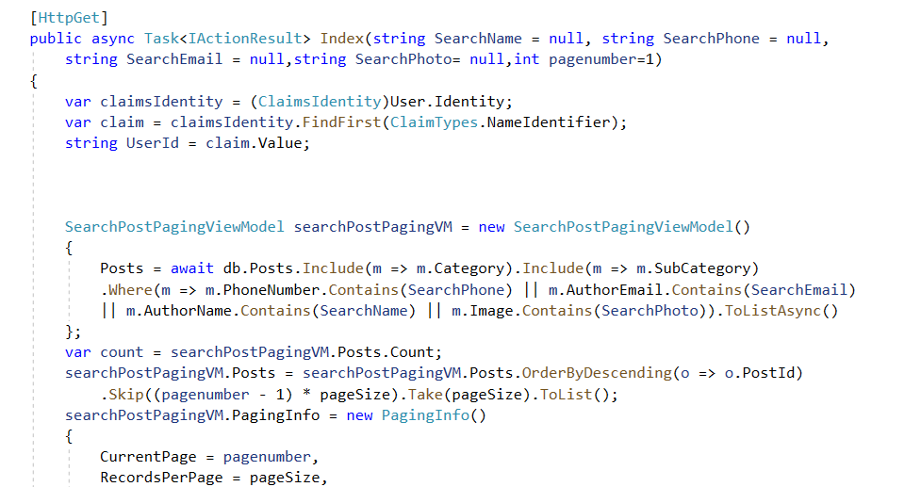List of Searched Posts:**

**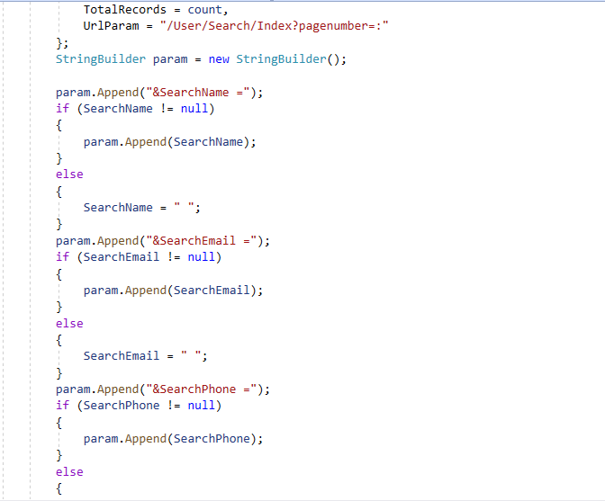**

**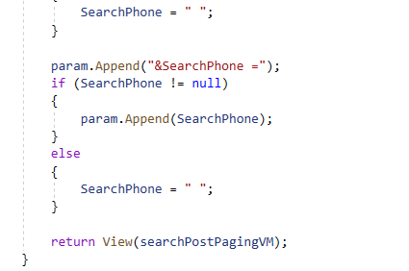**

* **Email Sender:**

**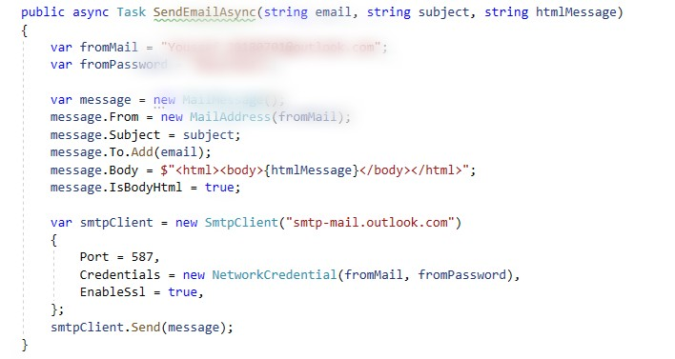**

* **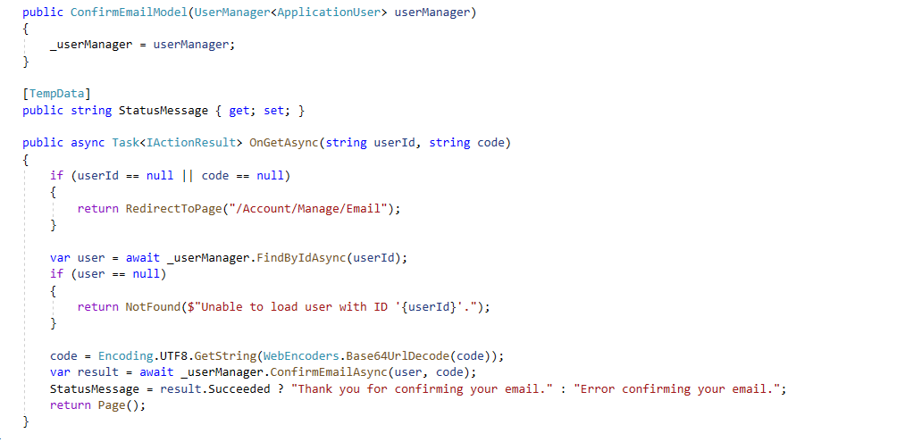Confirm Email:**

****

* **Delete Account:**

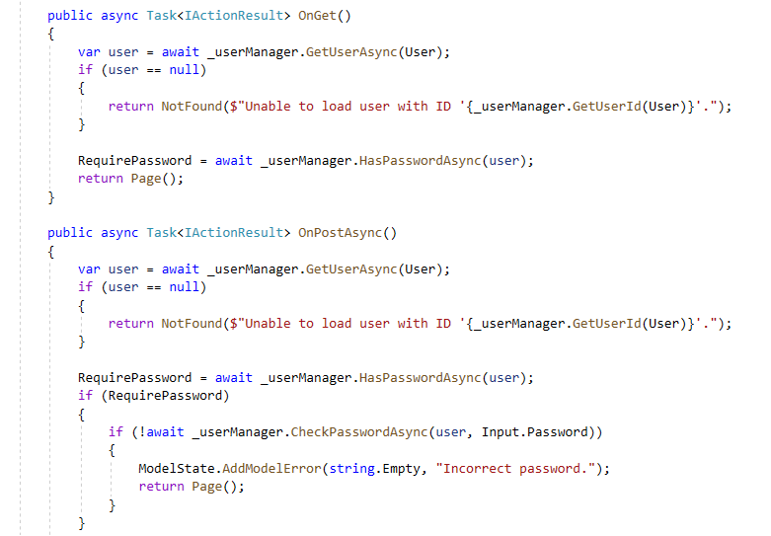

* 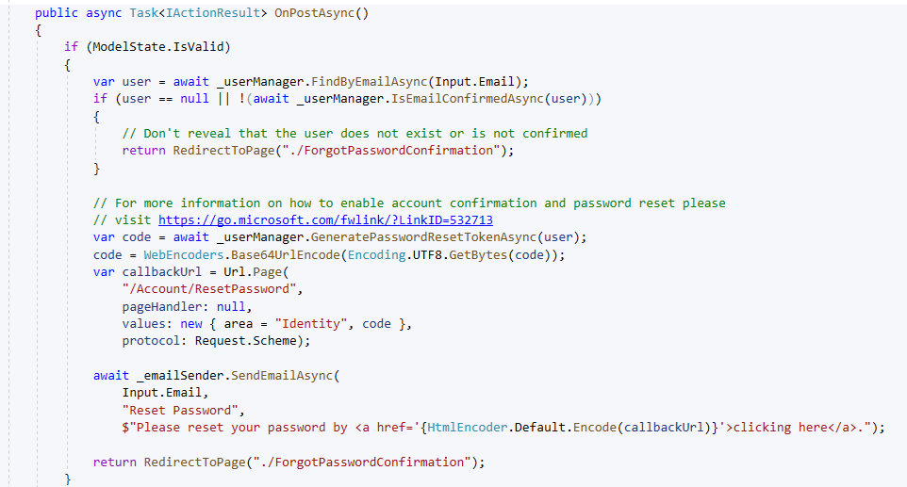**Forgot Password:**

****

****

* **External Login:**

**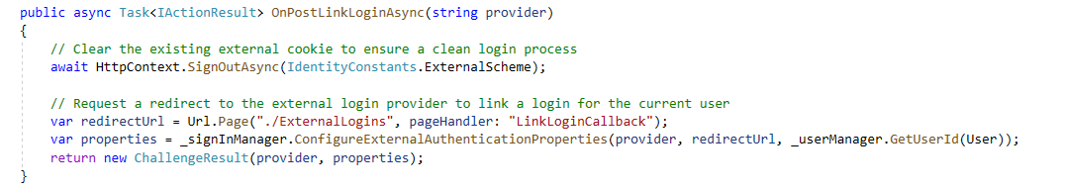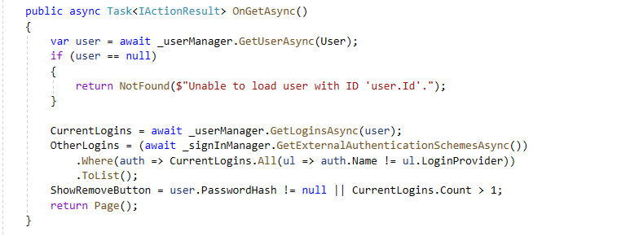**

****

* **Reset Password:**

**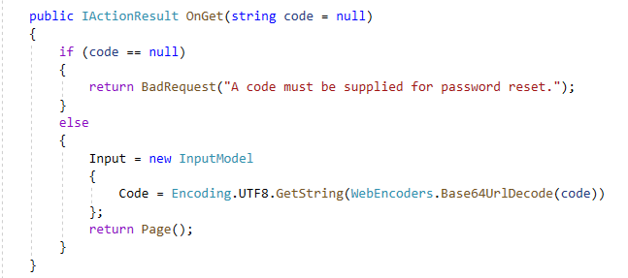**

**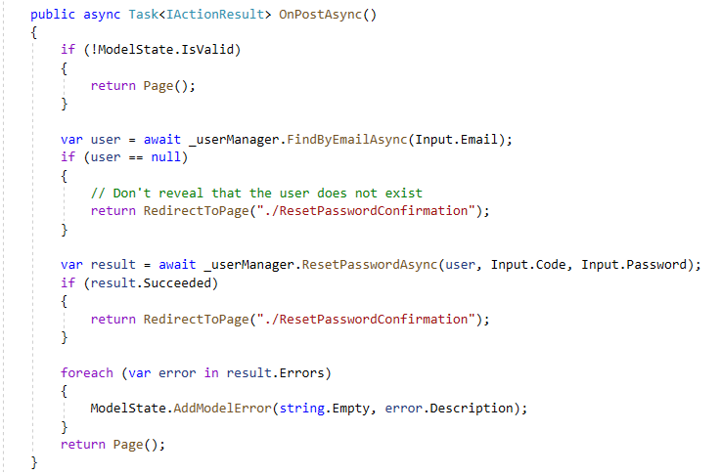**

****

* **Image Validation:**

**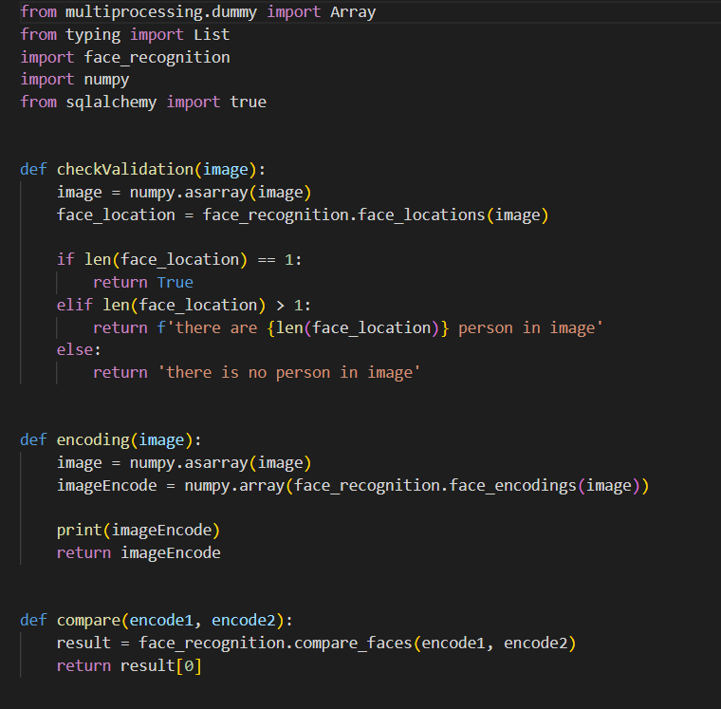**

****

****

* **Image Similarity:**

**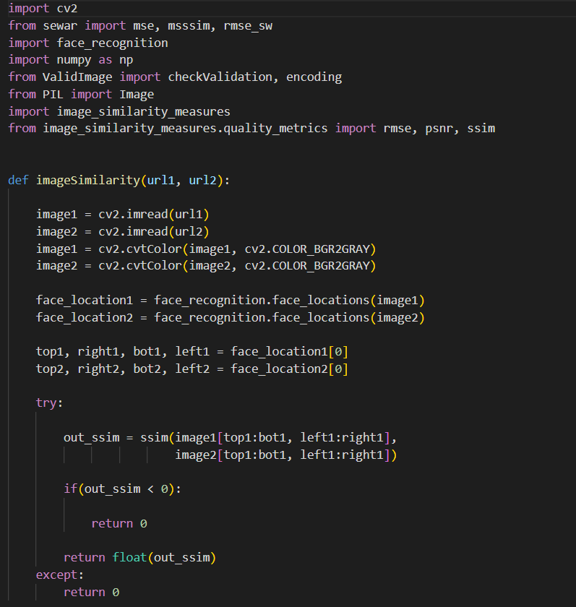**

****

* **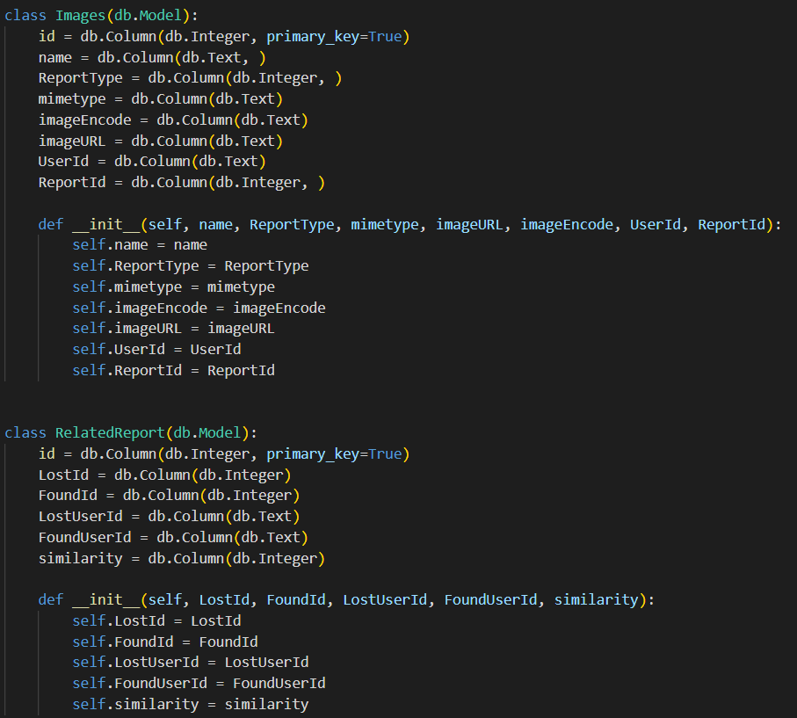Generate Report:**

**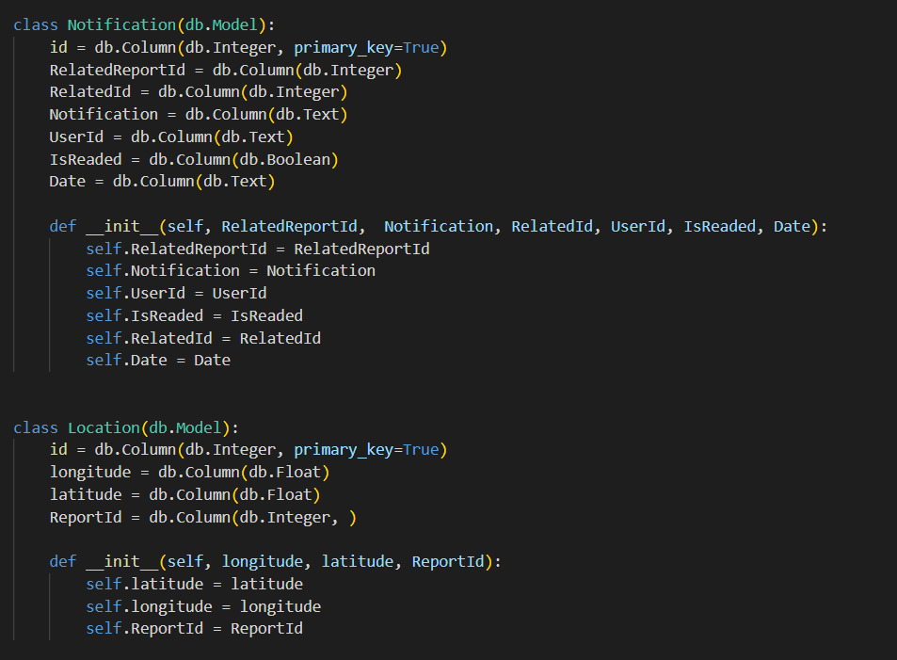**

****

* 1. **Pseudo Code, WorkFlow:**
* **If valid email and password**

**User logged in successfully**

* **Else**

**Error Message displayed Invalid**

**Email or password**

* **ElseIf**

**If user attempted five invalid login**

**User Account will be locked out**

* **If Admin try to Create a Sub-category with already existing name**

**Display Error Message**

* **Else**

**Sub-category added to the list of**

**Subcategories**

* **If user entered invalid inputs during post’s creation**

**Display Error Message**

* **Else**

**Post is submitted till approved by the admin**

* **If user’s post contain inappropriate or created spam posts**

**Post is rejected and user account will**

**be locked**

****

****

* **Else**

**User’s Post will be approved and**

**Added to the homepage**

* **If User Added Comment to post**

**Comment displayed below post**

**with author name, creation date**

* **If Application User changed email**

**Provide New Email**

**Server Sends confirmation email**

* **Else**

**Error Message Invalid email**

* **If user wants to delete account**

**Provide current password**

**If password is valid**

**Display Confirm deletion**

**Else**

**Invalid Password Message**

* **If user want to search post**

**Provide Author name, email**

**,phone number**

****

* **Else**

**No Posts are retrieved**

* **If user uploads image to search**

**API call to get posts data**

**Assign data to variables**

**Apply Image Similarity**

**Compare Uploaded image to**

**Post’s image**

**Generate Report to display result**

**Display Report to user**

* **Else**

**Display message Not Found.**

****

**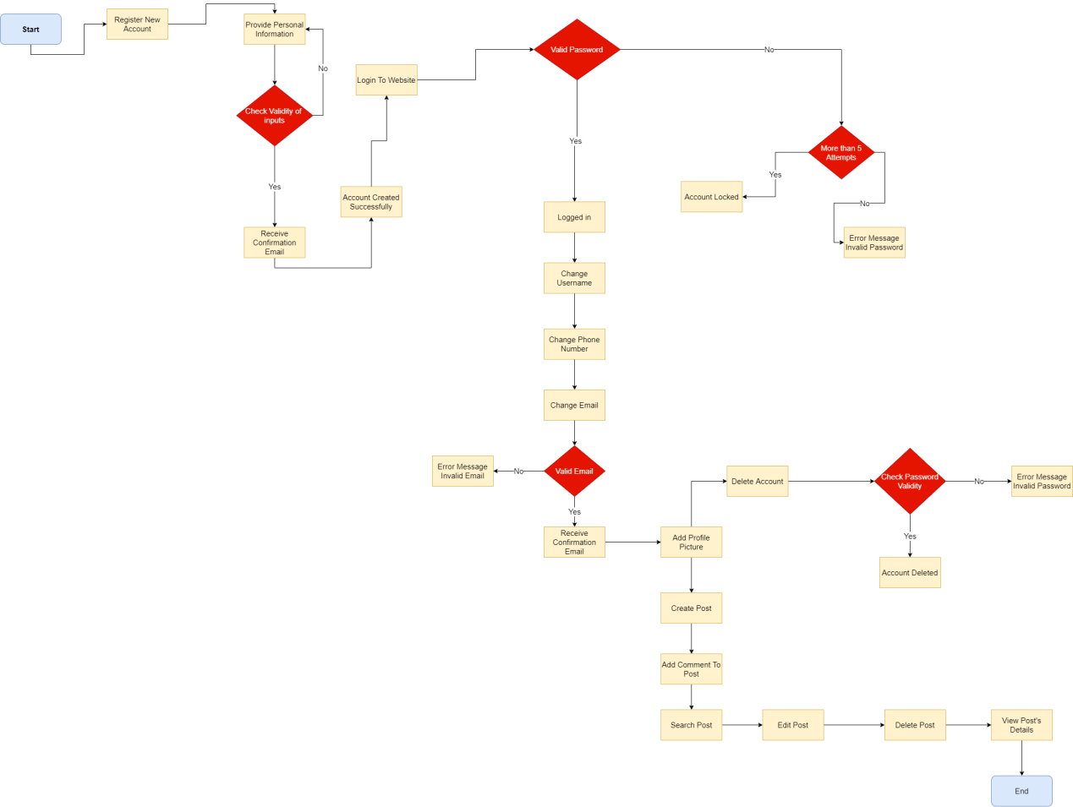**

****

**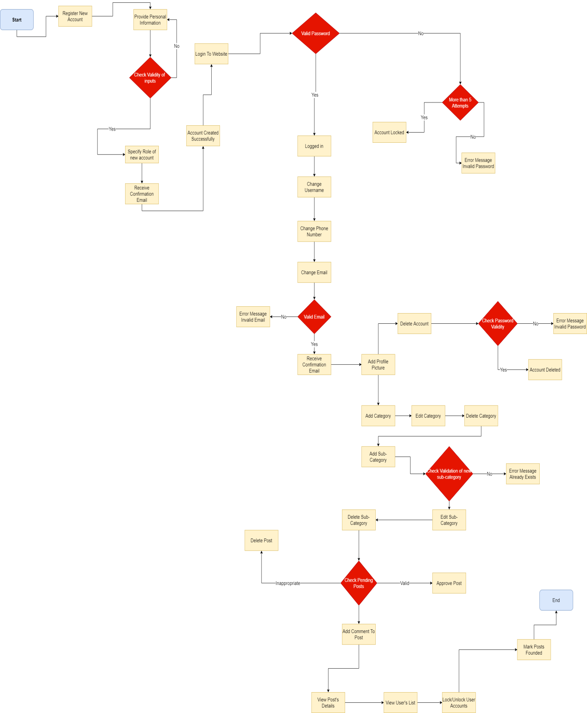**

****

**Chapter 5.**

**Testing**

****In this chapter we’re going to discuss and go deeper in settle web application’s testing, and present the types of testing to be used and test cases we examined our application through.

****

**5.1 Unit Testing:**

* Unit testing is testing of individual items (e.g. modules, programs, objects, classes, etc.) usually as part of the coding phase; in isolation from other development item stand the system as whole.
* Verify login successfully with correct email and correct password.
* Valid email: [youssefbenyameen@gmail.com](mailto:youssefbenyameen@gmail.com)
* Valid password: beny-123

|  |  |  |  |
| --- | --- | --- | --- |
| Steps | Description | Expected Result | Actual Result |
| 1 | Navigate to login screen | User navigate to login page |  |
| 2 | Enter email:  [youssefbenyameen@gmail.com](mailto:youssefbenyameen@gmail.com) | User can enter email |  |
| 3 | Press tab | Move to the password text field |  |
| 4 | Enter password:  Beny-123 | User can enter password |  |
| 5 | Click login button | User logged in and display homepage | Passed |

****

****

* Register to the website with valid email.
* Valid email: [youssefbenyameen@gmail.com](mailto:youssefbenyameen@gmail.com)
* Valid Password: beny-123
* Valid Zip-Code: 1251
* Valid Address: Giza-Haram

|  |  |  |  |
| --- | --- | --- | --- |
| Steps | Description | Expected Result | Actual Result |
| 1 | Navigate to register screen | User navigate to register screen |  |
| 2 | Enter name: Youssef Benyameen | User can enter username |  |
| 3 | Enter Email: [youssefbenyameen@gamil.com](mailto:youssefbenyameen@gamil.com) | User can enter email |  |
| 4 | Enter Phone-Number: 01245981236 | User can enter phone number |  |
| 5 | Enter Address:  37 Giza St. | User can enter address |  |
| 6 | Enter Zip code:  1251 | User can enter zip-code |  |
| 7 | Enter governorate: Giza | User can enter governorate |  |
| 8 | Enter Password:  Beny-123 | User can enter password |  |
| 9 | Press Register Button | Confirmation email sent to the email address entered by user |  |
| 10 | Press reference link sent to email | Register is done successfully and user can login to website | passed |

****

****

* ****Dealing with Posts.

|  |  |  |  |
| --- | --- | --- | --- |
| Steps | Description | Expected Result | Actual Result |
| 1 | Press My post from navigation bar above | User navigate to his post list |  |
| 2 | View list of user’s Posts | Display list of user’s post with paging to facilitate view |  |
| 3 | Press Create New button above | Navigate to create post form |  |
| 4 | Enter title | User must enter a title |  |
| 5 | Write description for post | User can enter description and choose font size, type |  |
| 6 | Upload Post’s image | User can upload image to the post |  |
| 7 | Enter address | User can enter address |  |
| 8 | Choose category | User can choose any category from categories’ list |  |
| 9 | Choose sub-category | User can choose any sub-category from sub-categories’ list related to chosen category |  |
| 10 | Press Create button | Post is submitted till approved by the admin | Passed |
| 11 | User can view post’s status | Display Current status of post either Approved or rejected |  |

****

* Application user dealing with profile features.

|  |  |  |  |
| --- | --- | --- | --- |
| Steps | Description | Expected Result | Actual Result |
| 1 | Press on username above in the navigation bar | Application user navigate to the profile page |  |
| 2 | Change username, phone number, upload an image | User can enter new username, enter new phone number, upload new profile picture |  |
| 3 | Click save button | Changes made by users successfully added to the website | Passed |
| 4 | Press on email reference link | User navigate to manage email page |  |
| 5 | Change email address | User receive confirmation email on email his/her entered |  |
| 6 | Check reference link sent to email | Email has changed successfully | Passed |
| 7 | Press change password reference link | User navigate to change password page |  |
| 8 | Change password | User provide old password, new password, and confirm new password |  |
| 9 | Click update password button | User password is updated successfully | Passed |

****



* Home Page Model:

|  |  |  |  |
| --- | --- | --- | --- |
| Steps | Description | Expected Result | Actual Result |
| 1 | Press on application name “Find Me” or on icon next to it | User navigate to home page of the website |  |
| 2 | Press on details button next to each post | User navigate to post’s details page |  |
| 3 | Enter comment in text field below each post | User can write comment on each post |  |
| 4 | Press submit green button | User’s comment is added to the post successfully | Passed |
| 5 | Press on paging button below home page | User can navigate between home pages and view posts |  |
| 6 | Choose category from button above each home page | User can filter post in each page according to the chosen category |  |

* Search Model:

|  |  |  |  |
| --- | --- | --- | --- |
| Steps | Description | Expected Result | Actual Result |
| 1 | Click on reference link Search post from navigation bar above | User navigate to search post page |  |
| 2 | Enter username, phone-number, or email | Retrieve posts related to the user’s input |  |
| 3 | Upload an image | Retrieve post that contain image similar to uploaded image |  |

****



**5.2 Integrated Testing:**

* Integration testing is testing interfaces between major (e.g. systems level application modules) and minor (e.g. individual programs or components) items with in an application which must interact with each other.
* Category model:

|  |  |  |  |
| --- | --- | --- | --- |
| Steps | Description | Expected Result | Actual Result |
| 1 | Press on category reference link from navigation bar above | Admin navigate to category page |  |
| 2 | View list of categories | Display list of categories available |  |
| 3 | Press create new button | Navigate to create category form |  |
| 4 | Enter category name | Admin can create new category |  |

****



* Sub-Category Model.

|  |  |  |  |
| --- | --- | --- | --- |
| Steps | Description | Expected results | Actual results |
| 1 | Press sub-category reference link from navigation bar above | Admin navigate to sub-category page |  |
| 2 | View sub-categories’ list | Display sub-categories’ list to admin |  |
| 3 | Press create new button | Navigate to create sub-category form |  |
| 4 | Select a category from list | Display already existing sub-categories under chosen category |  |
| 5 | Enter sub-category name | New sub-category added successfully to the system |  |

****



* Application user Model.

|  |  |  |  |
| --- | --- | --- | --- |
| Steps | Description | Expected Result | Actual Result |
| 1 | Press users reference link from navigation bar above | Admin navigate to application user page |  |
| 2 | View user’s list | Display users’ list to admin |  |
| 3 | Press green lock button | Admin can lock user’s account |  |
| 4 | Press red unlock button | Admin can unlock user’s account |  |
| 5 | Press create new button above | Register new user and navigate to registration form |  |
| 6 | Enter required data | Admin specify role of new account, enter username, email, address, etc. |  |
| 7 | Press register button | Receive confirmation link on email |  |
| 8 | Press confirmation link in email | New account added successfully to the website |  |

****



* Pending Post Model.

|  |  |  |  |
| --- | --- | --- | --- |
| Steps | Description | Expected Result | Actual Result |
| 1 | Press pending post reference link from navigation bar above | Admin navigate to pending post page |  |
| 2 | Click blue details button to view post’s details | Display post details to admin to review it |  |
| 3 | Click green approve button to approve post | Post approved and added to the home page |  |
| 4 | Click red reject button to remove post | Post deleted |  |

* Founded items Model.

|  |  |  |  |
| --- | --- | --- | --- |
| Steps | Description | Expected Result | Actual Result |
| 1 | Press posts reference link from navigation bar above | Admin navigate to unfounded items page |  |
| 2 | Click green founded button | Mark post as founded and remove it from home page |  |

****



**5.3 Additional Testing:**

Non-Functional

Functional

* We have discussed two types of Functional testing in the previous two points, but there are many other types of functional testing.
* System Testing; testing a system behavior as a whole when development is finished and the system can be tested as a whole entity.
* ****Regression Testing; check older functionality after integrating a new functionality.



* Acceptance Testing; testing to ensure that a development is ready to be deployed into the business, operational or production environment.
* We are going to discuss some of non-functional testing in our system.
* Performance Testing; accomplished a designated function regarding processing time and through put rate.
* Load Testing; measuring the behavior of within increasing load which can be handled by the component or system.
* Stress Testing; evaluate a system or component at or beyond the limits of its specified requirements.
* Security Testing; testing how well the system protects information against unauthorized internal or external access.

****



**Chapter 6.**

**Results & Discussions**

In this chapter we’re going to find out the results of the project whether they’ve achieved the requirements or not, and also the differences between the desired results and the actual ones

****